



Table of contents

**Expectations and objectives of the intervention**

Lenses

increase knowledge of hygiene and hand washing with soap

increase knowledge of antibiotics (bacteria/viruses)

explore the excessive use of antibiotics and its impact on health.

explain the link between poor hygiene and the excessive use of antibiotics.

co-develop changes in their behaviour regarding hygiene, hand washing and antibiotics

Optimising the use of antibiotics, including

Answer questions that may arise during activities

**Resources required**

Villages, framework and timetable

**Main theme of the intervention**

Community sellers

Members of the community

**Agenda for the first intervention round**

**Before the start of the operation**

Preparation

**Prepare the equipment** 9

**Meeting with community chiefs and leaders** 10

**FIRST ROUND OF COMMUNITY INVOLVEMENT 12**

**Details of days 13**

Day 1 details 13

Resources and equipment 13

**I.** **Les activités organisées dans la journée 13**

1.1. Visit by the chief/representative, community leaders and relays 13

1.2. Greetings from teachers at school 13

1.3. The door-to-door method 13

1.4. Personal meetings with informal vendors 14

1.5. Personal sessions with formal health workers 14

**1.6.** **Session de formation avec les vendeurs informels 14**

1.7. Resources 14

**II.** **Les activités organisées dans l’après midi 17**

2.1. Community event 17

2.1.1. Projection of animations/videos from youtube 17

2.1.2. Comic play 17

2.1.3. Educational talks on photovoice images 18

Details of day 2 20

Resources and equipment 20

**I.** **Les activités organisées dans la journée 20**

1.1. Personal sessions: Say hello to informal vendors 20

**1.2.** **Personal sessions: Greet the health**  workers20

1.3. **Training session**avec les agents de santé formels 20

1.4. Ad hoc meetings with men and women from the community: 21

**II.** **Les activités organisées dans l’après midi 22**

2.1. **Raising awareness on the**  themes22

**Day 3 in detail 26**

Resources and equipment 26

**I.** **Les activités organisées dans la journée 26**

**1.1.** **Visit informal drug sellers**. 26

2.2. **Visit to the health** au centre de santé 26

2.3. **School event.** Matériel 27

2.4. **Clock**: routine quotidienne 29

2.5. **Training session**avec les agents de santé 30

**SECOND ROUND OF COMMUNITY INVOLVEMENT 32**

Preparation: 2 days. 33

**Agenda for the second intervention round 34**

**Day 1 details 37**

Resources and equipment 37

**I.** **Les activités organisées dans la journée 37**

1.1. **Visit from the village**  chief37

1.2. Community cleanliness day 37

**1.3.** **Personal sessions with informal**  vendors37

1.3.1. **Greet informal**  vendors38

**1.3.2.** **Personal sessions: Visits to planned**  pharmacies38

**II.** **Les activités organisées dans l’après-midi 39**

2.1. Mapping defecation areas 39

2.2. Rapid mapping methodology 39

2.3. Educational talks 41

2.4.Theatre on hygiene and sanitation issues in the community 41

2.4. Film screening followed by discussion 42

Details of day 2 42

Resources and equipment 42

**I.** **Les activités organisées dans la journée et l’après midi 43**

1.1. School event 43

1.1.1.Tug-of-war 43

1.1.2.RAM shooting: a game about medicines 44

1.1.3. Stories about the **the boy nobody loves** and the one **of Aminata and Poko** 45

1.1.3.The clock: daily routine 45

1.2. Training session with formal health workers 46

**1.3.** **Visits to planned**  pharmacies48

1.4. Training with informal vendors 48

**THIRD ROUND OF COMMUNITY INVOLVEMENT 50**

**Agenda for the third intervention round 51**

**Details of day 1 52**

Resources and materials 52

**I.** **Les activités organisées dans la journée 53**

**1.1.** **Visit from the village**  chief53

1.2. **Personal sessions with informal**  sellers53

**1.3.** **Personal sessions and visits to pharmacies**  planned53

1.4. Ad hoc meetings with women and men from the community 53

1.5. Training session with pharmacists/vendors/community health workers 54

**II.** **Les activités organisées dans l’après midi 55**

2.1. Animated podium in a strategic corner of the market 55

2.2. Educational talks and discussions on the themes /photovoice 56

Details of day 2 56

**I.** **Les activités organisées dans la journée 56**

**Informal vendors** 56

**1.1.** **Visits to**  pharmacies57

**1.2.** Ad hoc meetings with women and men from the community 57

**1.3.** Training session with health workers 57

**II.** **Les activités organisées dans l’après midi 58**

**2.1.** Animated podium in a strategic corner of the market 59

**2.2.** Educational talks and discussions around themes /photovoice 59

**III.** **Les activités organisées dans la journée 60**

**3.1.** **Greet informal**  vendors60

**3.2. Visits to planned pharmacies** 60

3.3. Ad hoc meetings with women and men from the community 60

3.4. Training session with health workers 61

3.5. Animated podium in a strategic corner of the market 62

3.6. Educational talks and discussions on the themes /photovoice 62

**Appendix 64**

Theatre organised in the community during the first round of intervention 64

Scenario 64

Videos screened in the community during the first round 66

Hand washing with soap 66

Antibiotic resistance 66

Medication compliance 66

Invitation cards distributed in the first round 66

Photos and photovoice images used during the operation 67

Germs 75

The immune system 76

Quiz: Use of antibiotics 81

COMMUNICATION 82

Communicating clearly 83

Reacting with empathy 84

Steps to effective communication 86

Negotiation 88

communication and negotiation 90

Monitoring and evaluation form - CABU-EICO 93

ACCESS Antibiotics: 95

WATCH group Antibiotics: 105

Activity table with the different categories of the population 121

Infections frequently seen in primary care and choice of treatment 162

Acute fever without other signs 163

Antibiotics Acces / Watch found at the market 164

**Bibliographical references 165**

INTERVENTION GUIDE

# Expectations and objectives of the intervention

## Objectives

This community intervention has the following objectives:

### Increase knowledge of hygiene and hand washing with soap

### Increase knowledge of antibiotics (bacteria/viruses)

### Exploring the excessive use of antibiotics and its impact on health.

### Explain the link between poor hygiene and the excessive use of antibiotics.

### Co-develop changes in their behaviour regarding hygiene, hand washing and antibiotics

### Optimising the use of antibiotics, including

* reduce the use of antibiotics (mainly from the WATCH group) in primary care and/or in the community
* promote the use of antibiotics in accordance with a treatment guide

### Answer any questions that may arise during the activities

# Resources required

See each individual day

## Villages, framework and timetable

| Date of intervention in the village | 1e  lap  February-March-April | 2e tour  May-June-July | 3e tour  August-September-October |
| --- | --- | --- | --- |
| Villages |
| KOKOLO |  |  |  |
| POESSI |  |  |  |
| ZIMIDIN |  |  |  |
| BOLOGO |  |  |  |
| NAZOANGA |  |  |  |
| SOUM |  |  |  |
| DACISSE |  |  |  |
| KOURIA |  |  |  |
| BALOGO |  |  |  |
| NANORO |  |  |  |
| PELLA |  |  |  |

# Main theme of the intervention

## Community sellers

the importance of their role in the community

## Members of the community

Community members have the power to :

* make choices
* go to the health centre if you are ill/don't buy medicines without a prescription
* wash your hands with soap
* not to defecate in the open air
* taking care of yourself and your communities

# Agenda for the first intervention round

| **Day** | **Monday** | **Tuesday** | **Wednesday** | **Thursday** | **Friday** | **Saturday** | **Sunday** |
| --- | --- | --- | --- | --- | --- | --- | --- |
| village |
| KOKOLO |  |  |  | Organisation of the next village | Organisation of the next village | Organisation of the next village | Rest |
| POESSI |  |  |  | Organisation of the next village | Organisation of the next village | Organisation of the next village | Rest |
| ZIMIDIN |  |  |  | Organisation of the next village | Organisation of the next village | Organisation of the next village | Rest |
| BOLOGO |  |  |  | Organisation of the next village | Organisation of the next village | Organisation of the next village | Rest |
| NAZOANGA |  |  |  | Organisation of the next village | Organisation of the next village | Organisation of the next village | Rest |
| KOURIA |  |  |  | Organisation of the next village | Organisation of the next village | Organisation of the next village | Rest |
| DACISSE |  |  |  | Organisation of the next village | Organisation of the next village | Organisation of the next village | Rest |
| SOUM |  |  |  | Organisation of the next village | Organisation of the next village | Organisation of the next village | Rest |
| BALOGO |  |  |  | Organisation of the next village | Organisation of the next village | Organisation of the next village | Rest |
| NANORO |  |  |  | Organisation of the next village | Organisation of the next village | Organisation of the next village | Rest |
| PELLA |  |  |  | Organisation of the next village | Organisation of the next village | Organisation of the next village | Rest |

# Before the start of the operation

## Preparation

2 weeks. Resources: Invitation cards

### **Prepare the** equipment

Print all the material that needs to be printed, buy soap, buy the necessary snacks, print the material, the packaging and the WASH antibiotic logo, WASH antibiotics to buy. Prepare the necessary bags for the following week.

**Ensure that venues/rooms** are reserved for events

### **Meeting with community chiefs and leaders**

* Meet the leaders of the community (NB: ask the village chief for the best time of day, time of day, etc.) where you will be visiting the following week. Explain the activities you want to set up in the community and in the school. Explain why we have chosen this village and what will happen in each village: you will talk to the chiefs, talk to the children at school, talk to the medicine sellers, talk to the community. Explain and describe the week's activities and show the relevant photos chosen at the photovoice event. Keep the tone of the conversation friendly and respectful.
* Explain: It is important to wash your hands. Make a clear link between not washing your hands and illness and why this can reduce the (excessive) use of antibiotics and the harmful effects of this practice, using simple illustrations. Not taking antibiotics too often is important. Discuss how we are going to motivate people to wash their hands and not take too many antibiotics. Explain the importance of their support and how we need them:
* Could they say a few words about hand washing, sanitation and AMR at the community event, please?
* Could they give you some important information about the village? How many houses are there? Where are the churches, schools and water sources? Understand the different aspects of the village. Time when people might be available at home. Draw a map. **Discuss meeting places.**
* Ask for help in getting people together. Take the address and telephone number of the leaders so that you can call them for help. Ask which venue you can use for **the community event** and for **training informal vendors**. If necessary, obtain contact details. Confirm the times.
* Meeting with the CVD and/or ASBC of each village, during which they will be given the invitation cards for the concessions.
* Meeting with the school's teachers. Explain the importance of working with children at school and the importance of teachers for activities.
* Explain that you are going to organise some fun activities at school for the children. Thank the teachers for their support
* Meeting informal vendors. The researchers visit the informal sellers, either in the market or elsewhere. They encourage them to come to the training course during the intervention.
* Meeting with the head of the Nanoro health district and his team, presentation of the intervention and discussion on the involvement of the health district team (and remuneration if someone from the district health officer's office, for example a supervisory nurse, will have an active role in the intervention).

# FIRST ROUND OF COMMUNITY INVOLVEMENT

# Day details

## Day 1 details

### Resources and equipment

| Invitation card | Soaps | Cables |
| --- | --- | --- |
| Clinical algorithm | Banners | Giant clock |
| Paper | Posters | photovoice images |
| Pens | Sound system | Computer |
| Information on germs | Generator | Evaluation form |
| A bag with a range of antibiotics | Microphones |  |
| Quiz (antibiotics) | Intervention logo |  |
| Images of the most common WATCH antibiotics | Petrol |  |

# Activities organised during the day

## Visit from the chief/representative, community leaders and relays

The first village leaders (IC, CVD, ASBC, iman, catechist, youth leaders, women's representative, association representatives) will be invited to the chief's house to remind them of what needs to be done in the village.

## Greetings from the teachers at school

The aim is to remind the school's teachers of the activity that will be carried out in the said school or schools. Pupils will be mobilised according to the availability of teachers and pupils (every Wednesday).

## The door-to-door method

On the morning of the community event, the organisers, with the help of community informers and DVCs, will go door-to-door to distribute invitation cards for the event, which will take place in the evening. In addition to door-to-door canvassing, groups of people and passers-by will be given invitation cards to take part in the event. Around 3,300 invitation cards will be distributed.

## Personal sessions with informal vendors

**You'll need to say hello to the informal sellers** and remind them what you'll be doing that day. Sit down with them and ask if you can discuss the cases they are getting. Ask them what their main difficulties are and discuss them with them. Remind them about the training and tell them to come along. Today is all about building a relationship, so start slowly.

## Personal sessions with formal health workers

It consists of reminding the health workers what the trainer will be doing that day. Sit down with them and ask if you can discuss the cases they get for which they prescribe antibiotics. Ask them what the main difficulties are and discuss them with them. Today is all about building a relationship, so start slowly.

# Training session with informal vendors

It will be the first of two training sessions

## Resources

Paper, pens, quiz, information on the immune system, bag of antibiotics.

Say that you are going to start this visit by exchanging names: introduce yourselves and your role. Explain the purpose of the training.

Say that you're going to get to know each other a little better thanks to the "story of your name": you're both going to share the meaning of your names and whether you like them.

Establish **ground rules** for the sessions. Suggest rules that they may want to include, such as respect for each other's opinions, politeness, non-judgment, etc.

* **Brief discussion** of the immune system
* The purpose of the immune system is to help germs invade your body.
* The four main types of germ are viruses, bacteria, parasites and fungi.
* Getting vaccinated when you're young helps your immune system fight off disease.
* Being "immunised" means being protected
* When a person's immune system overreacts to a harmless substance, it is called an allergy.
* Smoking helps your immune system

Group discussion: bacteria and viruses. What are they and what do they do in the body? **(NB: name and highlight four pathogenic agents and their effects on the body; in what categories and how are viruses, bacteria, parasites and fungi transmitted?)**

Discuss how the development of antimicrobial agents has improved the chances of surviving common bacterial infections such as pneumonia. Explain that antimicrobial agents should only be used to treat bacterial infections, not colds or other viral infections, and that antimicrobial agents should be prescribed and used in accordance with evidence-based treatment guidelines.

Take out **a bag containing a range of antibiotics that are** usually sold in markets, and pour the antibiotics onto the floor/table. Ask everyone to look at the pills. Ask them to point out the ones they recognise and know. What are they used for? What effects do they have? Do they see such antibiotics regularly?

Discuss the categories of WATCH and ACCESS: and discuss the use of the WHO strategy to optimise the use of antimicrobial agents: Access, Watch and Reserve (AWaRe) to prevent the development of resistance and the WHO Model List of Essential Medicines (including the EML list for children). Which antibiotics on the table/floor are WATCH or ACCES antibiotics? Discuss broad and narrow spectrum agents.

Say that you are now going to discuss the results of the inappropriate use of antibiotics. (Reduced use of antibiotics Watch). Briefly explain AMR. Make the link between hand washing, illness and overuse of AMR. Explain the consequences in terms of economic burden, patient morbidity and mortality. Explain: the role of livestock, food and the environment in the acquisition and spread of antimicrobial resistance, common methods of spreading antimicrobial resistance among people. Explain how micro-organisms (particularly bacteria) evolve to become resistant to antimicrobial agents, and describe the main risk factors for the development of antimicrobial resistance.

Ask if you can sit with them tomorrow while they sell medicines to give them your support. Make a note of the time, address, etc.

Wrap up the session: Thank the participants for their time and congratulate them on continuing their journey towards health for the benefit of the community. Then ask them in turn to mention :

* one thing they learned today;
* something they're going to share with someone else; and
* something they're looking forward to doing before the next session.

# Afternoon activities

## Community events

Announce the event (music, etc). Announce the event an hour before it starts with music, etc.

Welcoming and settling in participants: introducing yourself to the audience. The time before the programme, while the audience is gathering, can be used to sing songs with the children, play jokes with the audience, sing film songs, and so on. It may take a while for the crowd to gather - keep them entertained with jokes and songs so they don't fall asleep.

Statement of support from the village president presenting the handwashing and AMR programme

### Showing of animations/videos from YouTube

Toofan song 'wash your hands' and on AMR: Video on antimicrobial resistance:

* <https://www.youtube.com/watch?v=C3X0FOUsnnc>
* <https://www.youtube.com/watch?v=_6JGi9Wj6UA> Wash your hands
* <https://www.youtube.com/watch?v=LtSz1IQGSas>

Next, set up the props for the play as it is presented by one of the presenters, who also gets the crowd involved: "What are their names? I can't hear you! What are they called?!"

* + 1. Comedy play

**"Neighbours: the consequences of drinking water from dams, wells, taking medicines, etc."**. This play depicts two people who are neighbours in a community, one being the person who is always ill and the other being the advisor on good practice. The sick person doesn't respect any rules of hygiene (never washes his hands, defecates everywhere, drinks dirty water, always buys medicines on the market for himself and his family, takes medicines when and where he wants). He will therefore confide in his neighbour, who attributes the consequences of his problems to certain causes/practices. The counsellor will give him advice, which he in turn accepts and promises to change.

It is aimed at adults. Make sure there are plenty of questions to keep the audience engaged: "Am I starting? ! Where is he?!" At the end, ask the audience questions again.

Then discuss the role that everyone plays in the health of the community. We must all wash our hands and take medicines responsibly. (NB: also stress the aspect of the social well-being of the most vulnerable: (we are responsible not only for your health but also for that of others) is very important. We do this not just for ourselves, but also to protect the weakest members of the community (babies, the elderly, the sick).

### Educational talks on photovoice images

Take the **photovoice photos** (**9** chosen beforehand) and present them to the crowd. Ask them what they can see in the photos? What do the photos show? Do they see similar things in their community? What do they see? Is it a problem? What are the problems? What are the solutions? Pledge ceremony. Members of the public are invited to come to the front to make a pledge (people will need to be encouraged to do this!): I will wash my hands with soap. I will take my medicines responsibly. I promise that I will always wash my hands with soap after defecating, before eating and after touching animals and dirt. "Down with RAM, no to open defecation, yes to hand washing with soap, yes to hygiene. Hygiene is life and power, let's make handwashing with soap our daily battle horse, down with RAM!"

Hand out **soap**.

Hand-washing facilities using soap in the concessions. During the community activity in the afternoon, each participant will be asked to set up a hand-washing facility. To do this, we will ask each head of household to fetch a bucket and soap, which will be placed in a corner of the compound. It will be up to the head of household to make sure that each member of the compound washes his or her hands with soap after returning from the toilet, before eating, feeding the children, cooking, after feeding the animals, etc. The bucket will be placed in a corner of the compound.

End with a song - from the children. End the session: Thank the participants for their time and congratulate them on continuing their journey towards health for the benefit of the community.

Storing equipment

Fill in the **evaluation and follow-up forms**. **(NB: remember to fill them in each time)**

## Details of day 2

### Resources and equipment

| Paper | Cables | Downloaded videos |
| --- | --- | --- |
| Pens | Projector | Soap |
| Treatment guides: diarrhoea | Sound system | Images from the photovoice project |
| Computer | Cables | Monitoring and evaluation forms |

# Activities organised during the day

* 1. Personal sessions: Say hello to informal vendors

Remind them what you are going to do that day. Sit down with them and ask if you can discuss the cases they are getting. Ask them what their main difficulties are and discuss them with them. Remind them about the training and tell them they need to come along. Tell them about the treatment of infant diarrhoea.

* 1. **Personal sessions: Greet the health workers**

Go to the health centre and remind them what you are going to do that day. Sit down with them and ask if you can discuss the cases they get for which antibiotics need to be prescribed. Conduct an audit of files and records. Ask them what the main difficulties are and discuss them with them. Talk to them about treating infant diarrhoea if there is time.

* 1. **Training session** with formal health workers

Welcome: Say hello and ask "how are you?

Explain that today you are going to discuss antimicrobial agents and the threat of antimicrobial resistance.

You will first discuss in groups of 2 (5 min) and then come back together to discuss and share what was said (10 min) about the current classification of antimicrobial agents (β-lactams, aminoglycosides, quinolones, etc.), and to explain the concept of broad-spectrum and narrow-spectrum antimicrobial agents.

Ask the group to form pairs, then, in each pair, each person describes the main properties of the classes of antimicrobial agents against bacteria Mechanism of action :

* Spectrum of activity
* Route of administration and bioavailability
* Dosage schedule
* Tissue penetration
* Half-life and clearance
* Undesirable effects

Ask participants to describe relevant co-morbidities, including drug allergies, which may influence the choice, dose and duration of antimicrobial agents.

Explain the relevance of age extremes and physiological conditions such as pregnancy and breastfeeding as risk factors for infection.

Explain the importance of the mechanisms by which organisms become resistant to antimicrobial agents: innate and acquired resistance mechanisms.

Thank the participants for the time they have devoted to the session and congratulate them on continuing their journey towards health for the benefit of the community. Then ask them to mention :

* one thing they learned today
* something they're going to share with someone else; and
* something they're looking forward to doing before the next session.
* Remind them of the training the next day.

During the training with the formal and informal health workers by the team of doctors, the social science team is active in ad hoc meetings with the men and women of the community. These ad hoc meetings are noted below.

* 1. Ad hoc meetings with men and women from the community :

These are short sessions designed to reach people who were unable to attend the community event the previous night. These are door-to-door visits by facilitators: walk from street to street looking for people who are ready to talk. The facilitators gather men, women and children in the street. The facilitators only have 10 minutes to get the message across. This session should therefore be short.

Facilitators discuss the campaign with groups of men and women; show animated films on a laptop.

[https://www.youtube.com/watch?v=C3X0FOUsnnc https://www.youtube.com/watch?v=_6JGi9Wj6UA](https://eur01.safelinks.protection.outlook.com/?url=https%3A%2F%2Fwww.youtube.com%2Fwatch%3Fv%3D_6JGi9Wj6UA&data=05%7C01%7CLinda.Campbell%40uantwerpen.be%7Cfc656af235eb4b52f7c708dab33b15ce%7C792e08fb2d544a8eaf72202548136ef6%7C0%7C0%7C638019363590831208%7CUnknown%7CTWFpbGZsb3d8eyJWIjoiMC4wLjAwMDAiLCJQIjoiV2luMzIiLCJBTiI6Ik1haWwiLCJXVCI6Mn0%3D%7C3000%7C%7C%7C&sdata=pK50uygSqhl3FPObiZr4UU7qV74TFUAgnbdQzQPDXhA%3D&reserved=0) <https://www.youtube.com/watch?v=LtSz1IQGSas>

# Afternoon activities

A podium is set up in a corner of the village chosen by the community.

Announce the event (music, etc.). Announce the event an hour before it starts with music, drums, etc.

Welcoming and settling in participants: introducing yourself to the audience. The time before the programme, while the audience is gathering, can be used to sing songs with the children, play jokes with the audience, sign film songs, and so on. It may take a while for the crowd to gather - keep them on their toes with jokes and songs so they don't fall asleep.

Words of welcome and start with the schoolchildren singing the country song.

Present the theme, taking into account the idea of **"our power".**

* 1. **Raising awareness on the following** themes

Waste management (household, animal, open defecation, etc.) in the community (NB: while associating the idea of antibiotics) PHOTOS OF WASTE from the photovoice project

**Causes:**

Lack of rubbish bins in concessions and in the community

Management of composting sites for field crops (briboko) on concessions and in the community

Animal management in concessions

They will certainly cite problems such as/ investigate further through questions (NB: focus on health risks)

Cases of animal theft explain the proximity between man and animal; the rearing of animals in or near concessions;

Lack of funds to build animal shelters

No pit for disposing of household waste

etc.

**Consequences/risks/ask them to name the consequences**

Contraction of illnesses caused by animals (colds, coughs...)

Failure to wash hands with soap causes germs to contract (leading to illnesses such as diarrhoea); touching dirty surfaces and rubbish causes illnesses (diarrhoea) when hands are not properly washed with soap).

Animal waste and household refuse are sources of odours (polluted, foul-smelling), and of the multiplication and proliferation of mosquitoes in the yard (source of malaria).

Consumption of meat from sick or dead animals is a source of illness and disease contraction

Etc

**Change behaviour/ask them for appropriate, local and sustainable proposals**

Dispose of rubbish away from concessions: dig holes or surround holes with bricks and burn rubbish frequently.

Avoid keeping animals in or near the compound/if not, set aside areas in the compound where animals can be tethered if there is no enclosure.

Always wash your hands with soap after touching or feeding animals

**Educational talks on the issue of household water conservation**

Interactive talk: show photos from Photovoice illustrating the problem of storing drinking water in households: problems with utensils, unsuitable places, etc.

Ask questions to stimulate debate on what's going wrong and what would be more appropriate for healthier water conservation in the concessions.

**Addressing the issue of water conservation** :

In the home, as it can be a source of exposure to disease: the most suitable place is where utensils (jars, canaries, cans) are well covered. Clean them well (cans, jars).

Recommend that every household own a funnel, so that when they come to draw water, everyone will have their own funnel, instead of the communal funnel lying around on the ground, causing contamination.

End with a song/music. End the session: Thank the participants for their time and congratulate them on continuing their journey towards health for the benefit of the community.

Raising awareness of **handwashing with soap**: causes, consequences and behaviour change (**NB: this should be combined with a discussion of antibiotics)**

**Causes**

Show the crowd the **photovoice photos** and ask them what they see - what are these photos about? They refer to :

Lack of soap in the community due to economic constraints ;

The population's lack of awareness of this hygiene practice, which is not included in their habits/behaviours, such as before meals, after using the latrines or touching animals. And also of the repercussions of not using soap in terms of exposure to disease;

Lack of water for washing (for those out in the field doing field work) Consequences

The absence of hand washing exposes people to the risk of contracting diseases (the most illustrative example here is Covid with the transmission of infectious diseases) and consequently to the (excessive) use of antibiotics.

Changes in behaviour

Prevent disease by washing hands, by making the practice of washing with soap (or using ash to scrub hands before washing with water) part of everyday life, to reduce exposure to disease and the overuse of antibiotics.

**The problem of antibiotic resistance (buying medicines without a prescription, buying medicines in markets, compliance with medicines, etc.).**

We will be looking at :

Promote an interactive exchange with members of the community

Talk about self-medication, which means buying antibiotics without a prescription.

Also address the issue of buying medicines in markets, shops and kiosks, as there can be risks associated with this practice (expiry date, counterfeiting, etc.).

The question of compliance refers to respecting and taking medication: buying and taking medication is done on the basis of a prescription/indication from a health worker. Talking about stopping medication after seeing an improvement and taking it again if there is a relapse for the same illness.

End with a song/music. Wrap up the session: Thank the participants for their time and congratulate them on continuing their journey towards health for the benefit of the community. Then thank everyone and tell them you'll be back in three months.

Storing equipment

Complete the **evaluation and monitoring forms**

# Day 3 in detail

## Resources and equipment

| Treatment guides: bronchitis, pneumonia, diarrhoea. | Commitment certificates | speakers (baffles) | petrol |
| --- | --- | --- | --- |
| Rope | Hand-washing station: buckets, soap and water | a backup generator | Cables |
| Clock | Paper and pens | a computer | History and stories |
| Soap | Photos photovoice | a microphone | monitoring and evaluation forms |

# Activities organised during the day

During the day, the team responsible for training formal/informal healthcare professionals will be giving their training, while the social science team will be carrying out activities in schools.

## **Visit informal drug sellers**.

Visit as many as possible before the training session. Discuss with them individual cases of drug sales and what they need to do. What questions do people ask? How should they respond? Tell them about bronchitis. Remind them about the training later.

## **Health workers visit** the health centre

Remind them what you are going to do that day. Sit down with them and ask if you can discuss the cases they get for which antibiotics need to be prescribed. Conduct an audit of files and records. Ask them what the main difficulties are and discuss them with them. Tell them about bronchitis. Show them the **treatment guides**.

## **School event.** Material

Accessories for the play, soap, giant clock.

With children:

A sketch about the disgusting nature of handling food without washing your hands and RAM.

Say hello to the children.

Start by cracking a few jokes with the children to lighten the mood and help everyone relax.

Begin the play by explaining what is going to happen - introduce the characters and state what the play is about. Then introduce the characters.

Then start the play.

Plays: tug-of-war **competition**

The play begins with music and the main character - the village queen! - enters with a rope. She is the "good" character. She explains that she's here because her friend Noonga-ringdo invited her to eat with him and challenged her to a games competition - tug-of-war. But where is he?

He arrives - not feeling well, moaning and clutching his stomach (this is a great opportunity for a comedic role: moaning, clutching his stomach, excessive coughing, sniffling and sneezing towards the audience. Disgust is a powerful motivator for behaviour change, and combined with humour it can be an effective method of promoting change). The queen asks him what's wrong. He replies that he doesn't feel well in his tummy. She asks him what happened that day to make him feel bad. He talks about what he did that morning - got up, went to the toilet, went to see the animals, ate, and so on. Each time, Reine asked him if he had washed his hands with soap, to which he replied that of course he hadn't! He continued to tell her about his morning routine until he finished at lunchtime. He didn't wash his hands at any point during the day!

The queen tells him that he must wash his hands with soap, that he has probably caught a disease because he didn't wash his hands with soap. She shows him how. She washes her hands with soap in a bucket and tells him that she washes her hands after going to the toilet, after touching animals or the floor, and before eating. He says "NO! I don't need to do that!" She asks him if he will wash his hands before eating. She asks him if he will wash his hands before eating. He replies "NO!" and then prepares Tô and Babenda for her to eat - full of disgusting ingredients like mud. When he's finished preparing the food, he offers it to her, and she says "NO". He offers it to the children, who all say no too!

The queen tells him that it's fine, they'll have their competition. They pull on the rope (it's also a good opportunity to play a more comical role) and, of course, the queen wins the game. Noonga-ringdo sits down in the mud and says he has to get better to win the game. He starts taking medicines/antibiotics out of his pocket and eating them like sweets - he even offers them to the children! The queen is horrified! She asks him what it is:

He says they're antibiotics. She asks him where he got them - didn't the doctor tell him how to use them? He replied that he'd bought them at the market. She tells him "No! it's not good" and explains why. She also explains what AMR is. He replies (in a stupid and comical way), for example, just make more medicines, it's not so bad, everything's fine, and she patiently answers his questions and explains why he's wrong. In the end, he leaves, saying he needs to defecate behind the school classroom. He comes back and she asks him if he's washed his hands. He replies that he hasn't! He then asks the children to join him in a game of tug-of-war - they have to shake his hand to join his team! With a bit of luck, the children say no and join the queen's team. The queen turns to the goat man and says: "You see?

If you want to be powerful, you have to wash your hands with soap and go to the doctor when you're sick - you don't have to buy medicines at the market any more, you don't have to defecate behind the classrooms!

Make it relevant to children - and make it funny! There should be one completely disgusting character, for comic effect, who has to be 'educated' by the other characters. Constantly repeat the idea that you have to wash your hands before doing anything. Show how to do it. At the end of the play, summarise the story and ask the children questions about what happened.

Story: tell the story of the **boy nobody likes** and that of **Aminata and Poko**

After the theatre and the discussion session on theatre and the story sessions with the children, we move on to the next activity:

Discuss **hand washing**, **illness** and **antibiotics**.

## **Clock**: daily routine

Discussion of everyday actions involving hand washing with soap

Show the children the clock. The characters describe their daily routine (the disguised character has a disgusting routine without washing his hands at all; the good character has a clean routine with lots of hand washing).

The children then participate and detail their daily routine - when they wash their hands and when they don't.

After a few children have talked (encourage applause for each child), reiterate the main messages about washing hands with soap after using the toilet, before eating and after touching soil or animals.

All children make a collective commitment: Commitment

Now tell the children: who is going to take up the challenge of being a champion, and fighting for their village, their family and themselves? How, and make a promise - raise your hands and promise to use soap to wash your hands and not to buy medicines at the market!

Say the promise one sentence at a time so that the children can repeat it after you:

* I promise to wash my hands with soap every time after the defection and before eating.
* I promise not to defecate in the open!
* I promise to see a health worker when I'm ill and not to buy any over-the-counter medicines!
* Down with RAM, no to open defecation, yes to hand washing with soap, yes to hygiene. Hygiene is life and power, so let's make handwashing with soap our daily battle-horse, down with AMR!

After saying this, give each child who has made his or her promise a bar of soap and ask the school to applaud.

The children make another pledge with the class to reaffirm their commitment. Give certificates to all the children.

A hand-washing station has been installed in the school playground;

Leaders supervise hand-washing before lunch: Set up the hand-washing station and ask the teacher to designate the pupils who will be responsible for doing it every day. Wash all the students' hands before lunch.

## **Training session** with health workers

We need paper and pens, and clinical algorithms

Welcome: Say hello and ask "how are you?

Ask participants to recount a good thing that has happened to them since the last session, and a challenge they have overcome (or are in the process of overcoming).

Do you have any questions about what we discussed yesterday?

Explain that today you are going to discuss **bronchitis, pneumonia and diarrhoea.**

Ask the health workers to divide into two groups: one group will discuss bronchitis and pneumonia and the other diarrhoea. In each group, they will describe (and write on paper) :

* how to assess the risk of infection in a patient.
* the importance of normal flora and distinguish between asymptomatic colonisation/carriage and active infection.

Come back together in the general group. Someone from the 'bronchitis' group (a reporter) summarises to the rest of the group the main points discussed in the sub-group. The people in the 'diarrhoea' group ask their questions. Then a reporter from the diarrhoea group does the same exercise and the group discussions continue.

Look at the **treatment guides** together. Try, briefly, to:

* Describe the pharmacodynamics and pharmacokinetics of antimicrobial agents, including combination therapy for the treatment of infection.
* Describe the use of AUC/MIC data and the concept of time- and concentration-dependent killing and persistent antimicrobial effect and how this affects the choice of antimicrobial agent, dosing regimen and mode of administration.
* Understand the need for therapeutic monitoring of medicines and when this is required.
* Describe the optimal dose, route of administration, dose interval and duration of antimicrobial therapy for a given clinical condition, as well as when to increase or decrease the dose.

Ask the group to form pairs and then, in each pair, ask them to discuss the nature of infection in special populations, including the complexities associated with their management, e.g. excessive alcohol and illicit drug users, the elderly, obese people, pregnant, post-partum and breastfeeding women, newborn babies, people with primary and secondary immunodeficiency, and people with liver and kidney failure. After 10 minutes, get back into a large group and discuss it together.

Do they have any questions?

Thank the participants for the time they have devoted to the session and congratulate them on continuing their journey towards health for the benefit of the community. Then ask them to mention :

* one thing they learned today;
* something they're going to share with someone else; and
* something they're looking forward to doing before the next session.

Fill in the evaluation form

# SECOND ROUND OF COMMUNITY INVOLVEMENT

## Preparation: 2 days.

Prepare the materials: print all the materials that need to be printed, buy soap, buy the snacks you need, print the materials. Prepare the bags needed for the following week.

Make sure the venues/rooms are reserved for events.

Meeting with community leaders

Meet/telephone the leaders of the community you will be visiting. Tell them about the activities you want to set up in the community and in the school. Explain the importance of their support and how we need them.

Ask which venue you can use for the community event and for training informal vendors. If necessary, obtain contact details. Confirm the times.

Meeting with the DDCs and/or ASBCs in each village

Meet the school's teachers. Thank the teachers for their support.

Meeting informal vendors. The researchers visit the informal sellers, either at the market or elsewhere. They encourage them to come to the training course during the intervention.

# Agenda for the second intervention round

| **Day** | **Monday** | **Tuesday** | **Wednesday** | **Thursday** | **Friday** | **Saturday** | **Sunday** |
| --- | --- | --- | --- | --- | --- | --- | --- |
| village |
| KOKOLO | And organisation of the following village | And organisation of the following village | And organisation of the following village | And organisation of the following village | And organisation of the following village | And organisation of the following village | And organisation of the following village |
| POESSI | And organisation of the following village | And organisation of the following village | And organisation of the following village | And organisation of the following village | And organisation of the following village | And organisation of the following village | And organisation of the following village |
| ZIMIDIN | And organisation of the following village | And organisation of the following village | And organisation of the following village | And organisation of the following village | And organisation of the following village | And organisation of the following village | And organisation of the following village |
| BOLOGO | And organisation of the following village | And organisation of the following village | And organisation of the following village | And organisation of the following village | And organisation of the following village | And organisation of the following village | And organisation of the following village |
| NAZOANGA | And organisation of the following village | And organisation of the following village | And organisation of the following village | * Organisation of the next village | * Organisation of the next village | And organisation of the following village | And organisation of the following village |
| KOURIA | And organisation of the following village | And organisation of the following village | And organisation of the following village | And organisation of the following village | And organisation of the following village | And organisation of the following village | And organisation of the following village |
| DACISSE | And organisation of the following village | And organisation of the following village | And organisation of the following village | * And organisation of the following village | * And organisation of the following village | * And organisation of the following village | * And organisation of the following village |
| SOUM | And organisation of the following village | And organisation of the following village | And organisation of the following village | And organisation of the following village | And organisation of the following village | And organisation of the following village | And organisation of the following village |
| BALOGO | And organisation of the following village | And organisation of the following village | And organisation of the following village | * And organisation of the following village | * And organisation of the following village | * And organisation of the following village | * And organisation of the following village |
| NANORO | And organisation of the following village | And organisation of the following village | And organisation of the following village | And organisation of the following village | And organisation of the following village | And organisation of the following village | * And organisation of the following village |
| PELLA | And organisation of the following village | And organisation of the following village | And organisation of the following village | And organisation of the following village | And organisation of the following village | And organisation of the following village | And organisation of the following village |

# Day 1 details

## Resources and equipment

| Directifs: treatment guides for skin and soft tissue infections | Soap | Yellow ochre (represents the colour of faeces) | Hand washer |
| --- | --- | --- | --- |
| Brooms, rakes, hoes, dabas, machetes, etc. (ask local people to send equipment) | Drinking water | Green powder (village boundary) | Monitoring and evaluation forms |
| Hand washing device | Muffler | Soap |  |

# Activities organised during the day

## **Visit from the village chief**

Remind them what you're going to do that day. The first village leaders (IC, CVD, ASBC, youth leader, women's leader, imam, catechist) will gather at the chief's house.

## Community clean-up day

The first day will be a **clean-up day** in these communities. To this end, unhealthy and busy areas will be identified in advance by the community. These could be markets, yaars, places of worship, places where people defecate, standpipes, etc.). In consultation with the chiefs and senior community leaders, we will divide the members present into groups for the clean-up.

Wherever this activity is carried out, we will ask the population and those in positions of responsibility to institute clean-up days (one clean-up day per month/the population can propose one); and another "international" clean-up day with the support of the district.

* 1. **Personal sessions with informal vendors**
     1. **Say hello to informal vendors**

Remind them what you are going to do that day. If they are currently involved in selling medicines, sit down with them and ask if you can discuss the cases they are getting. Ask them what their main difficulties are and discuss them with them. Talk to them about skin and soft tissue infections and antibiotics. Remind them about the training and tell them to come along.

### **Personal sessions: Visits to scheduled pharmacies**

Sit down with them and ask if you can discuss the cases they get where they prescribe antibiotics. Discuss how the prescription is made, any concerns and worries. Talk to them about skin and soft tissue infections and antibiotics. Show them the **treatment guides**.

Paper and pens, images and **treatment guides**.

* Welcome: Say hello and ask "how are you?
* Ask participants to recount a good thing that has happened to them since the last session, and a challenge they have overcome (or are in the process of overcoming).
* Do you have any questions about what we discussed the last time we met?
* Explain that today you are going to discuss **skin and soft tissue infections**.
* Ask the group to form pairs and then, in their pairs, discuss how often people buy antibiotics because of skin and soft tissue infections. What do their customers tell them? What do they usually do and prescribe?
* Then give each person a copy of the **clinical algorithms** for skin and soft tissue infections and antibiotics. Read the **treatment guides** out loud. Ask them to discuss in pairs. Give them 10 minutes. Then, with the whole group, ask them what they discussed.
* Thank the participants for the time they have devoted to the session and congratulate them on continuing their journey towards health for the benefit of the community. Then ask them to mention :
* One thing they learned today
* Something they're going to share with someone else; and
* One they're looking forward to doing before the next session
* Remind them of the training the next day

# Afternoon activities

## Mapping defecation areas

The idea is to help the communities to make a simple map on the ground showing houses, resources, defecation areas, water points and problems, in order to stimulate discussion. Ask them to choose an open area suitable for this exercise. Mapping involves all members of the community in a practical, visual analysis of the community's health situation. This activity should be undertaken in a spirit of collaboration, not moralizing! In the mapping exercise, all households should be asked to:

* Indicate their home on the map, using a marker on the ground for example, or by placing a leaf or a pebble,
* Indicate whether they have latrines.
* Indicate where you defecate in the open air
* Indicate wells, standpipes, dams, rivers, etc.
* Indicate main roads, schools, markets, etc.

## Rapid mapping methodology

Ask the villagers to assemble in a well-cleared area (preferably clean and dry, free of rubble, stones or grass).

Invite volunteers to sketch a quick line of the village boundaries using sticks, branches, coloured powders etc.

Ask someone to point out a few landmarks (schools, main roads, places of worship, etc. within the borders).

Then ask someone to point out where they have gathered.

Ask a young person to point to their house and stand in front of it.

Ask the others to check that she hasn't made a mistake, and if she has, ask them to applaud her.

The aim of this work is to help you find your way around the plan.

Now explain the following exercises to everyone:

* A single member of the family chooses a card (the pile of cards must remain outside the map); he then enters the layout and stands where his house is indicated.
* Ask them to write the name of the head of the family on the card and place it where he or she stands in the house (near his or her foot).
* Point out that the map represents their house. Then ask them to draw lines on the ground linking their house to the DAL zones. This will certainly provoke laughter and amusement, so leave it to them. Above all, do not hand out the cards or chalk to the members of the community; keep these materials in a corner of the map and ask them to go and get them themselves. Encourage movement and creativity.
* Pointing to the bag containing the yellow powder, tell them to show where they defecate in the open air. Tell them to spread more yellow powder where there is more excrement. This will generate even more laughter! Let them take the bag of powder themselves. There will be a rush to grab a handful of yellow powder. At this stage, the children will be pouring the yellow powder in places unknown to the parents.
* Allow time to complete the exercise
* Now ask everyone to come back and stand where their house is. Ask them where they go for urgent defecation, i.e. when it rains, in the middle of the night, during periods of severe diarrhoea or when they are ill, etc. Ask them to take some yellow powder and put it on the urgent defecation points. Ask them to take some yellow powder and put it on the points of urgent defecation. There will be a new burst of laughter and new piles of yellow powder around their house. People can say that in an emergency, they go behind their neighbour's house, and likewise, their neighbour comes behind their garden. Note that the map becomes increasingly yellow. Ask them if they think the whole village is full of excrement.
* Ask them all to leave the layout without moving the cards. In this way, a map of the houses was created.
* Remind them to wash their hands with soap.

## Educational talks

These educational talks will focus on the themes addressed in the photovoice images.

**Educational talks on photovoice images, followed by discussions and exchanges on the following themes:**

* Problems with hand washing with soap
* The problem of open defecation
* Antibiotic resistance (buying medicines without a prescription, buying medicines in markets, yaars and shops, compliance with medicines, etc.).
* The issue of drinking water conservation and storage in households
* Hygienic management of standpipes and traditional wells
* Managing toilet water run-off
* Management of household waste in concessions
* Unhealthy state of concessions and kitchens
* Animal husbandry in and around concessions
* The issue of the consumption of adulterated drinks

## 2.4. Theatre on hygiene and sanitation issues in the community

There are two characters. The first actor is a person who doesn't like hygiene. When you go into his compound, the animals live in the middle of the yard, the kitchen is very dirty, the dishes, pots, pans and plates are on the floor and flies land on them every time. During the winter, his entire plot is surrounded by grass. There is no hygiene in his plot.

The second actress is the opposite of the actor. She sweeps her plot every time, takes good care of her kitchen and so on. She goes to her neighbour's house to find that he's not at all hygienic. She offers to give him some advice, which he takes on board.

At the end of the play, the participants will discuss the issues raised by it.

## Film screening followed by exchange and discussion

Two films will be shown. The first screening will focus on antibiotic resistance (explanation of antibiotic resistance) https://www.youtube.com/watch?v=FSy_

The second is about Koko and the glasses. A film that deals with WASH issues and raises a number of questions https://www.youtube.com/watch?v=PCNLEK5Ityw

Thank participants and announce upcoming events. Put the equipment away and fill in the **evaluation and follow-up forms**, as well as taking a photo of the map.

## Details of day 2

### Resources and equipment

| Treatment guide for skin and soft tissue infections, acute fever without other signs and enteric fever | Hand washing station | Generator | Petrol | Rope |
| --- | --- | --- | --- | --- |
| Photos of the photovoice project featuring the themes of the first round | Treatment guide: acute fever without other signs and enteric fever | Pens | Computers | Cables |
| Treatment guide for skin and soft tissue infections, acute fever without other signs and enteric fever |  | Speakers | Microphones | Monitoring and evaluation forms |

# Daytime and afternoon activities

## School event

Materials: accessories for the game, soap, giant clock

Say hello to the children.

Start by cracking a few jokes with the children to lighten the mood and help everyone relax.

### 1.1.1. Tug of war

Start the game by explaining what is going to happen - Then launch the game. The game: **the children play tug-of-war and RAM tug-of-war. This time the children will play the game themselves.**

The children play **tug-of-war.**

For this game, two students are asked to volunteer to play tug-of-war. One represents the "normal person" and the other the "mud and dirt". They tug: if the normal person wins, say "now the normal person has gone out to play, feed the animals, etc. and there is now more mud on his hands" and add another child on the "mud" side. Repeat the game of tug-of-war.

Let's hope that at some point the "mud" will win! Now say "Now the normal person is going to wash his hands with soap and water". Choose children to represent the soap and water and add them to the side of the "normal person". Add enough of them so that they can easily win the game against the "mud" when the game starts again. **Repeat the message about hand washing.**

### 1.1.2. RAM shooting: drug game

Choose three children to play tug-of-war. Tell them that one of them represents a "normal person". But normal people don't wash their hands! So who does? Mud! And bacteria! So now it's two against one.

Let the children play tug-of-war, hoping that the normal person loses - if not, add other children to the mud and bacteria side to make sure they win. When the mud and bacteria have won, say "What can we do now? The normal person can take medicine!" Add three children to the "normal person" side to represent the medicines. Start the game again. With a bit of luck, the normal person and the medicines will win!

Now ask the children: "What happens if this person takes medicine without listening to what their doctor says? Or takes medicine every month without a doctor's prescription? (Wait for answers) ... yes, the bacteria learns to fight the medicine and becomes stronger! It becomes a

super-bacteria! It becomes resistant to the drug! Now ask other children to represent the "bacteria", so that there are many more children on the opposite side of the rope to the "normal" person and the medicine. Let them play tug-of-war again. With a bit of luck, the "bacteria" side will win! Then thank the children and ask them what happened when the bacteria became resistant to the drug. Ask them what the normal person did to get there.

Ask them what they can do to make sure they don't let the bacteria resist the medicine.

Once the children have finished introducing the games, we move on to the next activity: **the clock**: daily routine. This activity is repeated here because it lets the children know that washing their hands with soap is really vital for perfect health. This repetition will also help the children to change their practice quickly.

### 1.1.3. Stories about the **boy nobody likes** and about **Aminata and Poko**

Discuss hand washing, illness and antibiotics.

### 1.1.3. The clock: daily routine

Discussion of everyday actions involving hand washing with soap

* Show the children the clock. The characters describe their daily routine (the disguised character has a disgusting routine without washing his hands at all; the good character has a clean routine with lots of hand washing).
* The children then participate and detail their daily routine - when they wash their hands and when they don't.
* After a few children have talked (encourage them, applaud each child), reiterate the main messages about washing hands with soap after using the toilet, before eating and after touching soil or animals.
* All the children make a collective pledge: The pledge Now, tell the children: who is going to take up the challenge of being a champion, and fighting for their village, their family and themselves? How, and make a promise - raise your hands and promise to use soap to wash your hands and not to buy medicines at the market!
* Say the promise one sentence at a time so that the children can repeat it after you:
* I promise to wash my hands with soap every time after defecation and before eating.
* I promise not to defecate in the open!
* I promise to see a health worker when I'm ill and not to buy any over-the-counter medicines!
* Down with RAM, no to open defecation, yes to hand washing with soap, yes to hygiene. Hygiene is life and power, so let's make handwashing with soap our daily battle-horse, down with AMR!
* After saying this, give each child who has made their promise a bar of **soap** and ask the school to applaud.

A hand-washing station is set up in the school playground; facilitators supervise hand-washing. Set up the hand-washing station and ask the teacher to designate the pupils who will be responsible for washing hands every day. Wash the hands of all pupils before leaving the school.

## Training session with formal health workers

**Training session** with health workers: Paper and pens, clinical algorithms

Welcome: Say hello and ask "how are you?

Ask participants to recount a good thing that has happened to them since the last session, and a challenge they have overcome (or are in the process of overcoming).

Do you have any questions about what we discussed the last time we met?

Explain that today you are going to discuss **skin and soft tissue infections**, **acute fever without other signs and enteric fever.**

Discuss **skin and soft tissue infections** and the other **acute fever without other signs and enteric fever** :

* How to assess a patient's risk of infection.

Look at the **treatment guides** together. Are there any questions?

Explain the importance of normal flora and differentiate between asymptomatic colonisation/carriage and active infection.

Ask the group to form pairs and then, in each pair, ask them to discuss the nature of infection in special populations, including the complexities associated with their management, e.g. excessive alcohol and illicit drug users, the elderly, obese people, pregnant, post-partum and breastfeeding women, newborn babies, people with primary and secondary immunodeficiency, and people with liver and kidney failure. After 10 minutes, get back into a large group and discuss it together.

Do they have any questions?

Thank the participants for the time they have devoted to the session and congratulate them on continuing their journey towards health for the benefit of the community. Then ask them to mention :

* one thing they learned today;
* something they're going to share with someone else; and
* something they're looking forward to doing before the next session.
* Remind them of the training the next day.

**Training session** with health workers (Second of two training sessions on this tour): Paper and pens. Clinical algorithms.

Welcome: Say hello and ask "how are you?

Ask participants to recount a good thing that has happened to them since the last session, and a challenge they have overcome (or are in the process of overcoming).

Do you have any questions about what we discussed the last time we met?

Explain that today you are going to discuss the safe use of antimicrobial agents.

Put the group into pairs. Ask them to discuss in pairs the importance of safe and responsible use of antimicrobial agents. Then come back to the large group and discuss what has been said.

Ask the group to describe the common signs and symptoms of antimicrobial toxicity and toxicity related to bone marrow, liver and kidney failure. Write what they say on the flipchart and add details. Ask the group to explain the importance of therapeutic monitoring of certain antimicrobial agents to ensure clinical efficacy and reduce toxicity.

Divide the group into two groups. Ask the first group to discuss common drug allergies (immediate, non-life-threatening and life-threatening), and interactions involving other therapeutic agents (including other antimicrobial agents) and certain foods/alcohols. Ask the second group to discuss the negative consequences of antimicrobial agents on normal microbial flora and the risk of secondary bacterial or fungal infections. Then come back to the large group and discuss what has been said.

Group discussion: the risk of using broad-spectrum antimicrobial agents, i.e. the development of Clostridium difficile infection and multi-resistant infections due to selection pressure.

Put the group into pairs. Ask them to discuss in pairs the risk of antimicrobial resistance and how it might affect routine patient care and spread into the healthcare environment and the community. Then come back to the large group and discuss what has been said. Explain the safe disposal method for unused antimicrobial agents.

Conclude the session and thank the participants for their time and congratulate them on continuing their journey towards health for the benefit of the community.

* 1. **Scheduled visits to pharmacies**

Sit down with them and ask if you can discuss the cases they get where they prescribe antibiotics. Discuss how the prescription is made, any concerns and worries. Talk to them about **acute fever without other signs and enteric fever, and antibiotics**. Show them the **treatment guides**.

## Training with informal vendors

**Greet the informal sellers** and remind them of what you are going to do. If they are currently involved in selling medicines, sit down with them and ask if you can discuss the cases they are getting. Ask them what their main difficulties are and discuss them with them. Talk to them about **acute fever without other signs, enteric fever and antibiotics**. Remind them about training and the need to come to the clinic.

Welcome: Say hello and ask "how are you?

Ask participants to recount a good thing that has happened to them since the last session, and a challenge they have overcome (or are in the process of overcoming).

Do you have any questions about what we discussed the last time we met?

Explain that today you are going to discuss antibiotics, **acute fever without other signs and enteric fever**.

Ask the group to form pairs and then, in their pairs, discuss how often people buy antibiotics because of **acute fever without other signs and enteric fever**. What do their customers tell them? What do they usually do and prescribe?

Then give each person a copy of the **treatment guides** for **acute fever without other signs and enteric fever** and antibiotics. Read the **treatment guides** out loud. Ask them to discuss in pairs. Give them 10 minutes. Then, with the whole group, ask them what they discussed. Then review the treatment.

Thank the participants for the time they have devoted to the session and congratulate them on continuing their journey towards health for the benefit of the community. Then ask them to mention :

* one thing they learned today;
* something they're going to share with someone else; and
* something they're looking forward to doing before the next session.
* Remind them of the training the following round.

Putting equipment away and completing **evaluation and monitoring forms**

# 

# THIRD ROUND OF COMMUNITY INVOLVEMENT

Preparation: 2 days.

Prepare the materials: print all the materials that need to be printed, buy soap, buy the snacks you need, print the materials. Prepare the bags needed for the following week.

Make sure **the venues/rooms are reserved** for events.

Meeting with community **leaders**

Meet/telephone the leaders of the community you will be visiting. Tell them about the activities you want to set up in the community and in the school. Explain the importance of their support and how we need them.

Ask which venue you can use for **the community event** and for **training informal vendors**. If necessary, obtain contact details. Confirm the times.

Meeting with the CVD and/or ASBC in each village

Meeting informal vendors. The researchers visit the informal sellers, either at the market or elsewhere. They encourage them to come to the training course during the intervention.

# Agenda for the third intervention round

| **Day**  **village** | **Monday** | **Tuesday** | **Wednesday** | **Thursday** | **Friday** | **Saturday** | **Sunday** |
| --- | --- | --- | --- | --- | --- | --- | --- |
| KOKOLO |  |  |  | Organisation of the next village | Organisation of the next village | Organisation of the next village | Rest |
| POESSI |  |  |  | Organisation of the next village | Organisation of the next village | Organisation of the next village | Rest |
| ZIMIDIN |  |  |  | Organisation of the next village | Organisation of the next village | Organisation of the next village | Rest |
| BOLOGO |  |  |  | Organisation of the next village | Organisation of the next village | Organisation of the next village | Rest |
| NAZOANGA |  |  |  | Organisation of the next village | Organisation of the next village | Organisation of the next village | Rest |
| KOURIA |  |  |  | Organisation of the next village | Organisation of the next village | Organisation of the next village | Rest |
| SOUM |  |  |  | Organisation of the next village | Organisation of the next village | Organisation of the next village | Rest |
| DACISSE |  |  |  | Organisation of the next village | Organisation of the next village | Organisation of the next village | Rest |
| BALOGO |  |  |  | Organisation of the next village | Organisation of the next village | Organisation of the next village | Rest |
| PELLA |  |  |  | Organisation of the next village | Organisation of the next village | Organisation of the next village | Rest |
| NANORO |  |  |  | Organisation of the next village | Organisation of the next village | Organisation of the next village | Rest |

# Day 1 details

## Daily resources and materials

| Communication and negotiation guides | Photos of RAM | Posters of Access and Watch antibiotics found in markets | Monitoring and evaluation forms |
| --- | --- | --- | --- |
| Photos of hand washing | Algorithm for the management of acute fever | Tongue depressor | Back-up generator for villages without electricity |
| Petrol | Computer | Cables |  |

# **Activities organised during the day**

## **Visit from the village chief**

Remind them what you're going to do that day. The first village leaders (IC, CVD, ASBC, youth leader, women's leader, imam, catechist) will gather at the chief's house.

## **Personal sessions with informal vendors**

Remind them what you are going to do that day. If they are currently involved in selling medicines, sit down with them and ask if you can discuss the cases they are getting. Ask them what their main difficulties are and discuss them with them. Remind them about the training and tell them that they need to come along. Talk to them about effective communication with their clients. Show them the **treatment guides**.

## **Personal sessions and visits to pharmacies planned**

Sit down with them and ask if you can discuss the cases they get where they prescribe antibiotics. Discuss how prescribing is done, concerns and worries. Talk to them about **effective communication with their clients.** Show them the **treatment guides**.

## Ad hoc meetings with women and men from the community

These meetings can be held in the fields, as we will be in the middle of winter. They will also be held in concessions, yaars, markets and gathering places. These ad hoc meetings will cover all the issues raised in the first and second rounds.

The subjects we can discuss with people could be the **consequences of defecation in the fields: a** source of contamination for food from the fields (bito leaves, bulvanka, spinach, kinnebdo, beans, etc.).); household hygiene (random rubbish, grass around the house is a source of mosquito proliferation and therefore causes malaria; kitchen hygiene; avoiding stagnant water in and near the concessions; avoiding raising animals in the concessions, etc.).

Show and discuss **photos on RAM**

Show and discuss **photos of hand washing** (especially in winter, abdominal pains increase following the consumption of fruit without having washed it, etc.).

## Training session with pharmacists/vendors/community health workers

Welcome: Say hello and ask "how are you?

Ask participants to recount a good thing that has happened to them since the last session, and a challenge they have overcome (or are in the process of overcoming).

Explain that today you are going to discuss communication with customers, so that you can negotiate better with customers when it comes to antibiotics.

Practising communication and negotiation :

* Tell participants that positive communication is important and that you can help them find ways to have conversations with their customers. Say that you are going to practise positive and assertive communication together;
* Ask participants to think of a time when they sold antibiotics to a customer, and they felt that the customer pressured them to buy a certain antibiotic, or they felt that the customer wanted to buy a certain drug when another might have been better. Ask for volunteers to tell everyone what happened.
* Ask the interviewees to identify the mistakes the two characters make when communicating and give all the participants the opportunity to identify the communication mistakes and discuss what they would have done differently if they had been in that position. Do men or women have more or less power over each other in life and how does this affect communication?
* Discuss what makes communication effective in general and in difficult conversations (discuss the "principles for effective communication" in the resources).
* Put the participants into pairs. Then ask them to practise negotiating with a customer who wants to buy antibiotics. They can draw on their own experiences or invent a situation. Everyone presents their role-play to the others.
* Debriefing: how did it go? What was better/weaker? What good lines came out of the role-play? What helped or hindered communication during the exercise?

To conclude the role-play on a positive note, ask participants to say: What I like to see most every day is...

Ask them how they experienced the exercise. Was it difficult, challenging or interesting?

Discussing communication with customers, so as to be able to negotiate better with customers when it comes to antibiotics.

Thank the participants for their time and congratulate them on continuing their journey towards health for the benefit of the community. Then ask them to mention :

* one thing they learned today;
* something they're going to share with someone else; and
* something they're looking forward to doing before the next session.
* Remind them of the training the next day.

# Afternoon activities

The winter season is a time when people in the community are extremely busy working in the fields. People spend most of the day in the fields. Afternoon activities can take place during the village market day.

## Animation stand in a strategic corner of the market

**An evening** (entertainment podium in the villages: market day or a place popular with the community) with music in the market, including awareness-raising activities on the themes of the first and second intervention rounds.

Musical entertainment in public places (particularly in markets on market day)

### Educational talks and discussions on a range of topics /photovoice

* Problems with hand washing with soap
* The problem of open defecation
* The issue of antibiotic resistance
* The issue of drinking water conservation and storage in households
* Hygienic management of standpipes and traditional wells
* Managing toilet water run-off
* Management of household waste in concessions
* Unhealthy state of concessions and kitchens
* Animal husbandry in and around concessions
* Consumption of adulterated drinks

End with a song/music. Thank the participants for the time they have devoted to the session and congratulate them on continuing their journey towards health for the benefit of the community.

Put the equipment away and fill in the evaluation and follow-up forms.

### Details of day 2

# Activities organised during the day

### **Informal vendors**

Remind them what you are going to do that day. If they are currently involved in selling medicines, sit down with them and ask if you can discuss the cases they are getting. Ask them what their main difficulties are and discuss them with them. Remind them about the training and tell them they need to come along. Talk to them about the actual negotiation with their clients.

## **Visiting pharmacies**

Sit down with them and ask if you can discuss the cases they get where they prescribe antibiotics. Discuss how prescribing is done, concerns and worries. Talk to them about **the actual negotiation with their clients**.

### Ad hoc meetings with women and men from the community

These meetings can be held in the fields, as we will be in the middle of winter. They will also be held in concessions, yaars, markets and gathering places. These ad hoc meetings will cover all the issues raised in the first and second rounds.

The subjects we can discuss with people could be the **consequences of defecation in the fields: a** source of contamination for food from the fields (bito leaves, bulvanka, spinach, kinnebdo, beans, etc.).); household hygiene (random rubbish, grass around the house is a source of mosquito proliferation and therefore causes malaria; kitchen hygiene; avoiding stagnant water in and near the concessions; avoiding raising animals in the concessions, etc.).

Show and discuss **photos on RAM**

Show and discuss **photos of hand washing** (especially in winter, abdominal pains increase following the consumption of fruit without having washed it, etc.).

## Training session with health workers

Welcome: Say hello and ask "how are you?

Ask participants to recount a good thing that has happened to them since the last session, and a challenge they have overcome (or are in the process of overcoming).

Do you have any questions about what we discussed last time?

Explain that today you are going to discuss communication with customers, so that you can negotiate better with customers when it comes to antibiotics.

Practising communication and negotiation :

* Tell the participants that positive communication is important and that you can help them find ways of having conversations with their customers. Say that you are going to practise positive and assertive communication together.
* Ask participants to think of a time when they sold antibiotics to a customer, and they felt that the customer pressured them to buy a certain antibiotic, or they felt that the customer wanted to buy a certain drug when another might have been better. Ask for volunteers to tell everyone what happened.
* Ask the interviewees to identify the mistakes the two characters make when communicating and give all the participants the opportunity to identify the communication mistakes and discuss what they would have done differently if they had been in that position. Do men or women have more or less power over each other in life and how does this affect communication?
* Discuss what makes communication effective in general and in difficult conversations (discuss the "principles for effective communication" in the resources).
* Put the participants into pairs. Then ask them to practise negotiating with a customer who wants to buy antibiotics. They can draw on their own experiences or invent a situation. Everyone presents their role-play to the others.
* Debriefing: how did it go? What was better/weaker? What good lines came out of the role-play? What helped or hindered communication during the exercise?

# Afternoon activities

The winter season is a time when people in the community are extremely busy working in the fields. People spend most of the day in the fields. Afternoon activities can take place during the village market day.

## Animated stand in a strategic corner of the market

**An evening** (entertainment podium in the villages: market day or a place popular with the community) with music in the market, including awareness-raising activities on the themes of the first and second intervention rounds.

Musical entertainment in public places (particularly in markets on market day)

## Educational talks and discussions on a range of topics /photovoice

* Problems with hand washing with soap
* The problem of open defecation
* The issue of antibiotic resistance
* The issue of drinking water conservation and storage in households
* Hygienic management of standpipes and traditional wells
* Managing toilet water run-off
* Management of household waste in concessions
* Unhealthy state of concessions and kitchens
* Animal husbandry in and around concessions
* Consumption of adulterated drinks

End with a song/music. Thank the participants for the time they have devoted to the session and congratulate them on continuing their journey towards health for the benefit of the community.

Put the equipment away and fill in the evaluation and follow-up forms.

Details of day 3

# Activities organised during the day

## **Say hello to informal vendors**

Remind them what you are going to do that day. If they are currently involved in selling medicines, sit down with them and ask if you can discuss the cases they are getting. Ask them what their main difficulties are and discuss them with them. Remind them about the training and tell them that they need to come along. Talk to them about effective communication with their clients. Show them the **treatment guides**.

## **3.2. Visits to planned pharmacies**

Sit down with them and ask if you can discuss the cases they get where they prescribe antibiotics. Discuss how prescribing is done, concerns and worries. Talk to them about effective communication with their customers.

Show them the **treatment guides**.

## Ad hoc meetings with women and men from the community

These meetings can be held in the fields, as we will be in the middle of winter. They will also be held in concessions, yaars, markets and gathering places. These ad hoc meetings will cover all the issues raised in the first and second rounds.

The subjects we can discuss with people could be the **consequences of defecation in the fields: a** source of contamination for food from the fields (bito leaves, bulvanka, spinach, kinnebdo, beans, etc.).); household hygiene (random rubbish, grass around the house is a source of mosquito proliferation and therefore causes malaria; kitchen hygiene; avoiding stagnant water in and near the concessions; avoiding raising animals in the concessions, etc.).

Show and discuss **photos on RAM**

Show and discuss **photos of hand washing** (especially in winter, abdominal pains increase after eating fruit without washing it, etc.).

## Training session with health workers

Welcome: Say hello and ask "how are you?

Ask participants to recount a good thing that has happened to them since the last session, and a challenge they have overcome (or are in the process of overcoming).

Do you have any questions about what we discussed the last time we met?

Explain that today you are going to discuss the management and governance of antimicrobials.

Ask participants to describe the vital role played by the pharmacist in antimicrobial stewardship - what are the pharmacist's unique roles and responsibilities? What is the pharmacist's contribution to the appropriate use of antimicrobial agents? Write their suggestions on the flip chart.

Explain local patterns of antimicrobial resistance. Explain the WHO strategy for optimising the use of antimicrobial agents: Access, Surveillance and Reserve (AWaRe) categorisation. Explain the importance of prescribing policies and processes for monitoring use.

Divide the group in two, and give each group paper and pens. Ask each group to discuss:

* The importance of a 48- to 72-hour review of all antimicrobial prescriptions to verify optimal duration and prevent overuse.
* How local antimicrobial resistance patterns should be used to guide antimicrobial use.
* Explain the importance of restricted reporting of susceptibility data by the microbiologist in controlling the use of antimicrobials.
* Broad or narrow spectrum therapy when considering AMR

Discuss with the whole group the importance of prior authorisation of certain antimicrobial agents and the role of the pharmacist in achieving this safely and without risk to patients.

Ask the salespeople what three things they have learned that they think are going well/that they feel positive about as a result of all the sessions? Ask them what three things they would like to improve or plan to do in the future.

Thank the participants for their time and congratulate them on continuing their journey towards health for the benefit of the community. Then ask them to mention :

* one thing they learned today;
* something they're going to share with someone else

Thank the participants for the time they have devoted to the session and congratulate them on continuing their journey towards health for the benefit of the community.

Put the equipment away and fill in the **evaluation and follow-up forms**

## Animated stand in a strategic corner of the market

**An evening** (entertainment podium in the villages: market day or a place popular with the community) with music in the market, including awareness-raising activities on the themes of the first and second intervention rounds.

Musical entertainment in public places (particularly in markets on market day)

## Educational talks and discussions on a range of topics /photovoice

* Problems with hand washing with soap
* The problem of open defecation
* The issue of antibiotic resistance
* The issue of drinking water conservation and storage in households
* Hygienic management of standpipes and traditional wells
* Managing toilet water run-off
* Management of household waste in concessions
* Unhealthy state of concessions and kitchens
* Animal husbandry in and around concessions
* Consumption of adulterated drinks

End with a song/music. Thank the participants for the time they have devoted to the session and congratulate them on continuing their journey towards health for the benefit of the community.

Put the equipment away and fill in the evaluation and follow-up forms.

# Appendix

## Theatre organised in the community during the first round of intervention

### Scenario

**Neighbour 1 goes to see Neighbour 2**: he clutches his stomach with a tight face as he heads for his neighbour's plot (this can be as grotesque and comical as you like!).

**Neighbour 2**: Hey neighbour, what's going on? What's wrong?

**Neighbour 1**: It's really not going well. I've had abdominal pains for almost three days now. It also hurts a lot when I urinate.

**Neighbour 2**: Oh, it's really tricky isn't it, neighbour... all this for you alone? What could have caused this? Please tell me... what kind of water do you drink?

**Neighbour 1**: Look at my neighbour... I drink what kind of water! I drink the water from the dam and the wells... all my children, my wives, everyone drinks it.

**Neighbour 2**: Oh, now I understand... I know where your tummy troubles come from. (He tells her about the risks of drinking water from dams. He gives a detailed explanation)

**Neighbour 1:** Ahn good neighbour, I had no idea that water from dams and badly maintained wells had such a huge impact on our health. Thank you very much for your advice. From now on, I'm making a firm resolution to drink clean water. I could, for example, boil the well water before drinking etc.).

**Pause: the audience has the floor (**who can give the main message of this first part? All those who decide not to drink this water raise their hands etc.).

**Second scene:** behaviour around antibiotic resistance

**Neighbour 2**: Have you been to the health centre for treatment?

**Neighbour 1**: My health centre... not at all. At the market the day before yesterday I went to buy amoxicillin and ciprofloxacin and today I went to the shop next door where I bought toupaye zou sablélé (black-headed capsule) and toupaye zou miugu (red-headed capsule). All these medicines I take to swallow, I take one tablet in each pack and swallow them all at the same time. When I feel well, I stop; when it starts again, I do the same thing. My wife buys toupaye moondé (orange capsules) to treat my baby's kotiguè (mycosis).

**Neighbour 2:** Hey, hey, hey neighbour. You know what we call antibiotic resistance. But you want us to bury you. If you die, we'll bury you and carry on drinking our dolo. You've got a lot of problems on your own. Firstly, you haven't been to the health centre for a check-up, secondly, you're swallowing medicines from the market... only you'll die if you don't change your behaviour... Thirdly, you're taking medicines at random. Hey neighbour, don't you know you're exposing your family and members of the community to resistance?

**Neighbour 1:** Ah, you're a neighbour too, with all that information...you're scaring me, aren't you...tell me a bit about everything you're saying. You know, we don't have all the information, we're often ignorant. Please explain a little.

**Neighbour 2:** OK, open your eyes and ears wide, and your bum too if you want. (The actor explains what resistance is, its drawbacks, the importance of going to the health centre, and how he can be a source of contamination: defecating in the open etc.).

Assembly: we give the floor to the assembly... so we ask them questions about what they have understood; then a discussion is opened within the assembly to see what they propose to change these behaviours and also how they think they will put this into practice?

## Videos shown in the community during the first round of presentations

### Hand washing with soap

<http://www.superamma.org/download-English.html>

<https://www.youtube.com/watch?v=LtSz1IQGSas>

### Antibiotic resistance

<https://www.youtube.com/watch?wordv=C3X0FOUsnnc>

### Medication compliance

[https://www.youtube.com/watch?v=_6JGi9Wj6UA](https://eur01.safelinks.protection.outlook.com/?url=https%3A%2F%2Fwww.youtube.com%2Fwatch%3Fv%3D_6JGi9Wj6UA&data=05%7C01%7CLinda.Campbell%40uantwerpen.be%7Cfc656af235eb4b52f7c708dab33b15ce%7C792e08fb2d544a8eaf72202548136ef6%7C0%7C0%7C638019363590831208%7CUnknown%7CTWFpbGZsb3d8eyJWIjoiMC4wLjAwMDAiLCJQIjoiV2luMzIiLCJBTiI6Ik1haWwiLCJXVCI6Mn0%3D%7C3000%7C%7C%7C&sdata=pK50uygSqhl3FPObiZr4UU7qV74TFUAgnbdQzQPDXhA%3D&reserved=0)

## Invitation cards distributed in the first round of intervention



## Photos and photovoice images used during the operation

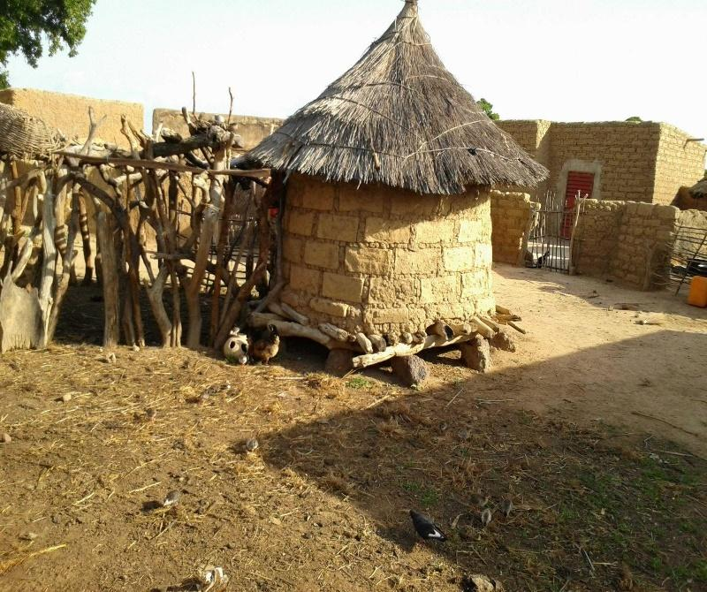

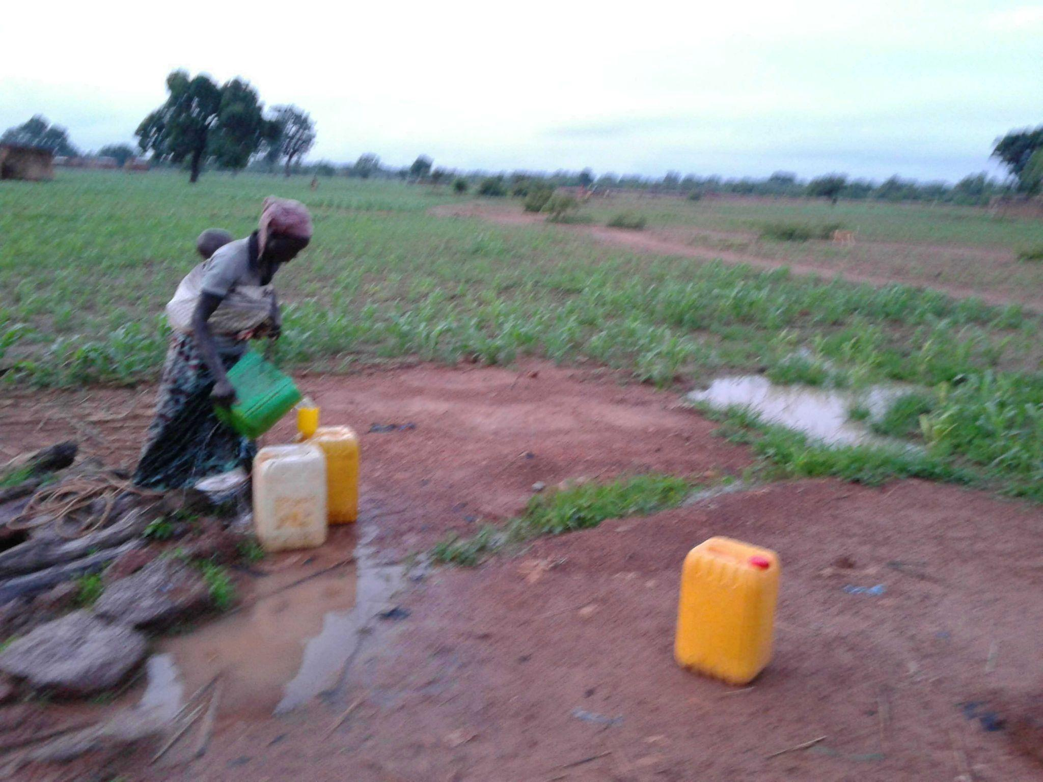

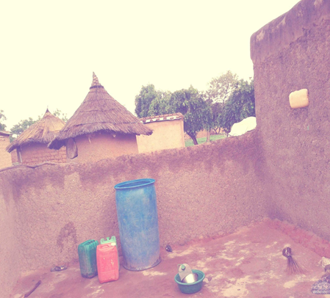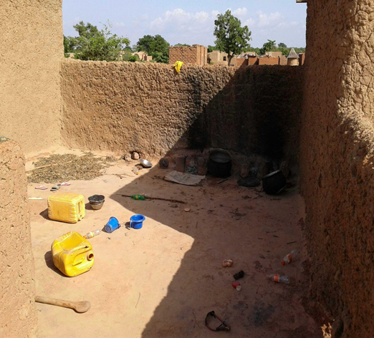

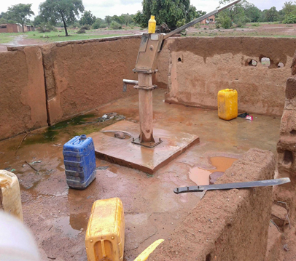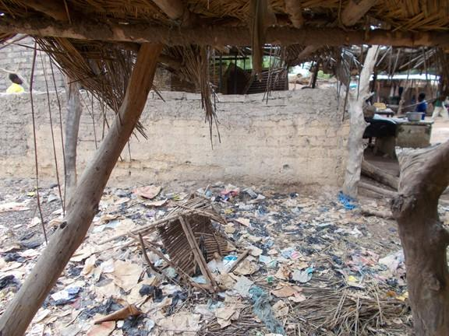

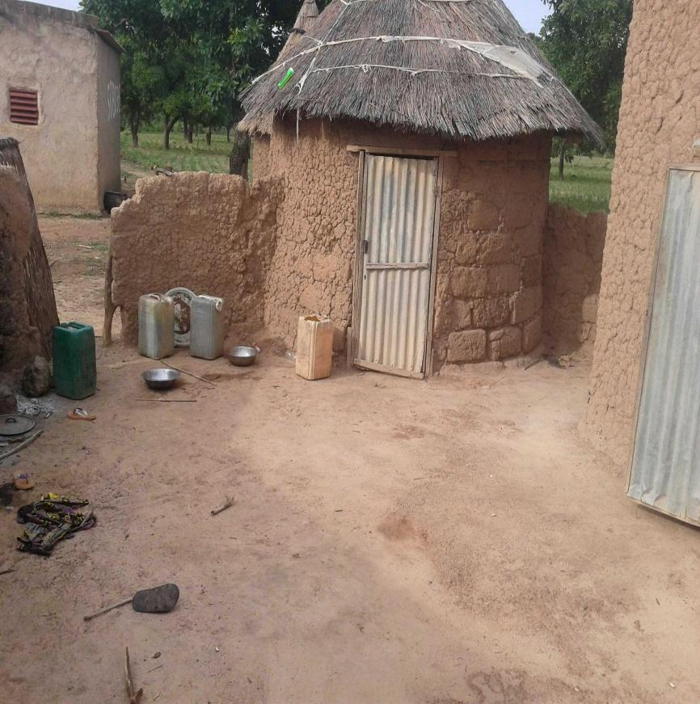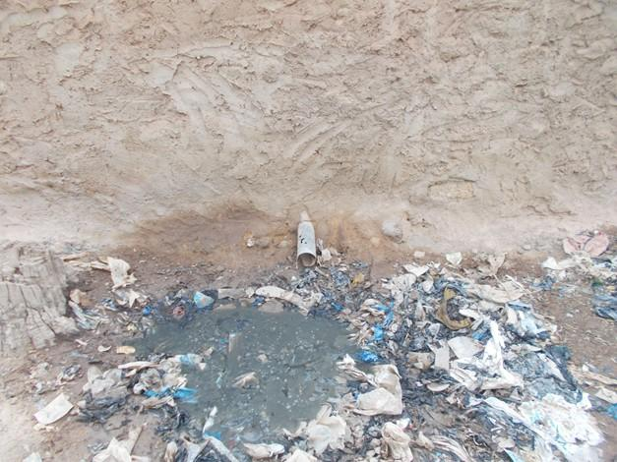

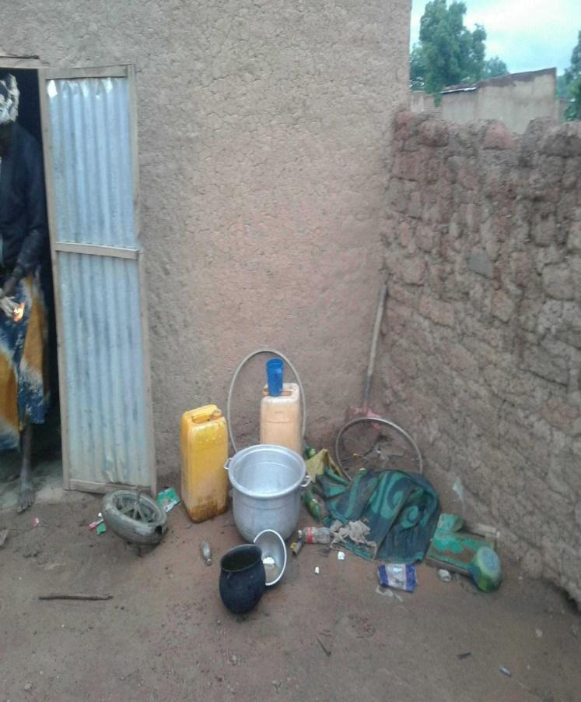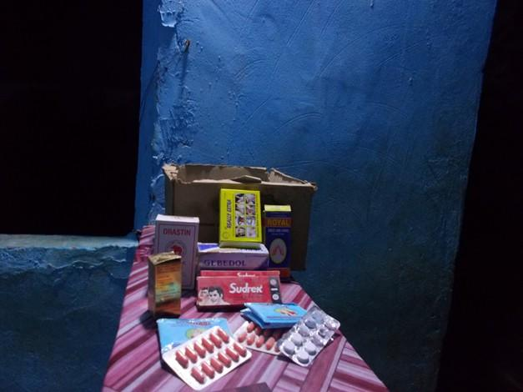

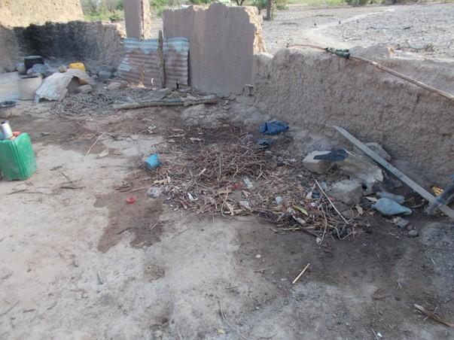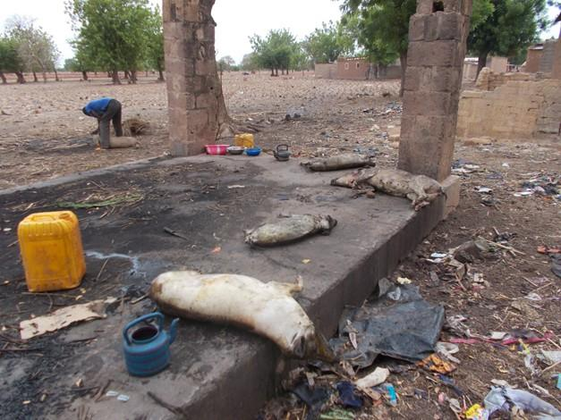

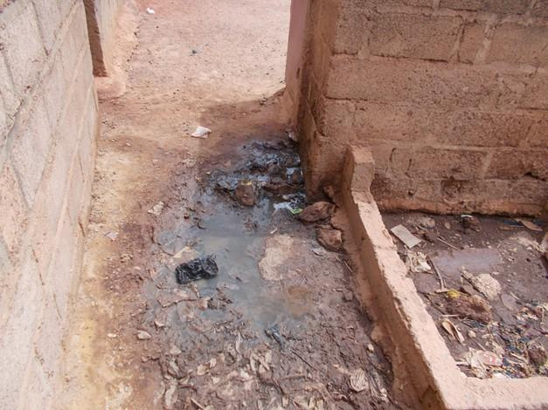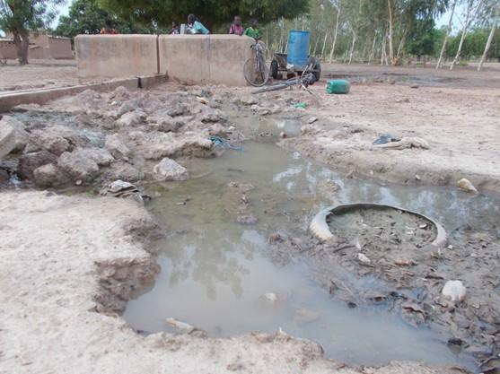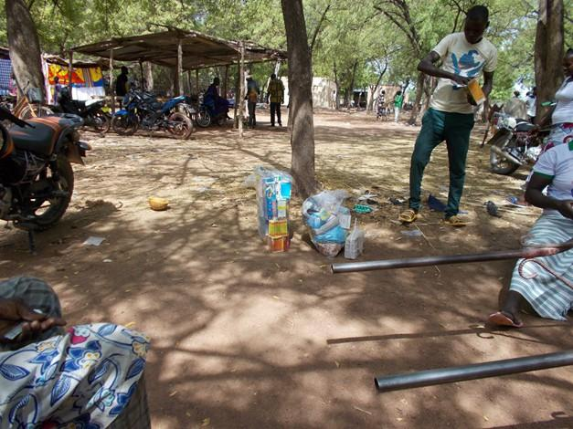

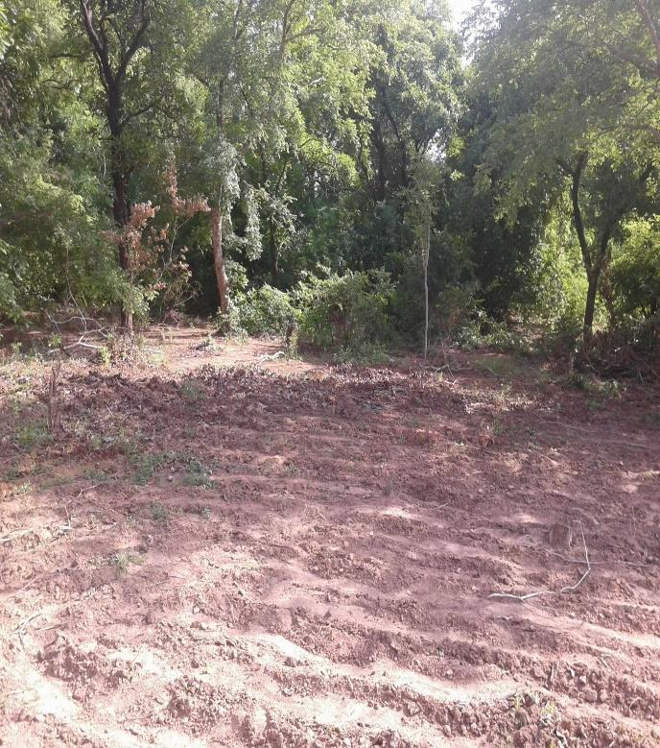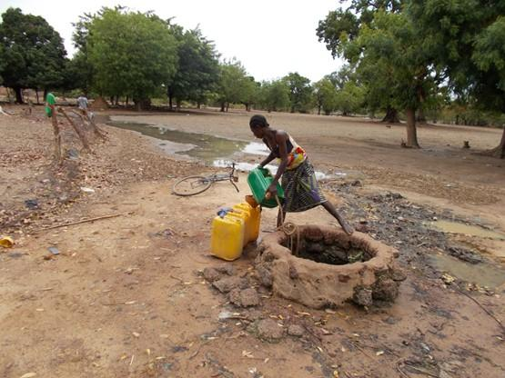

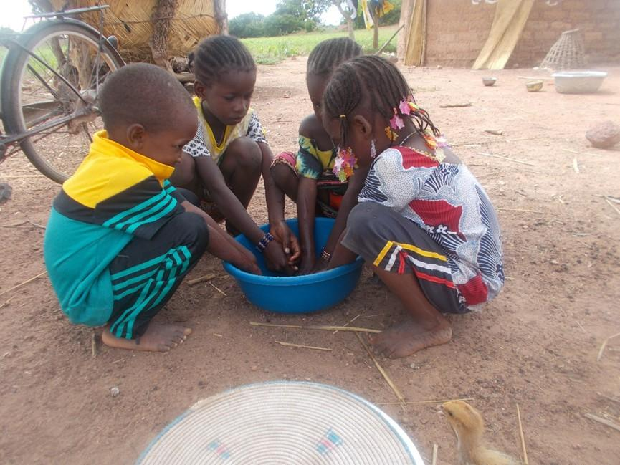

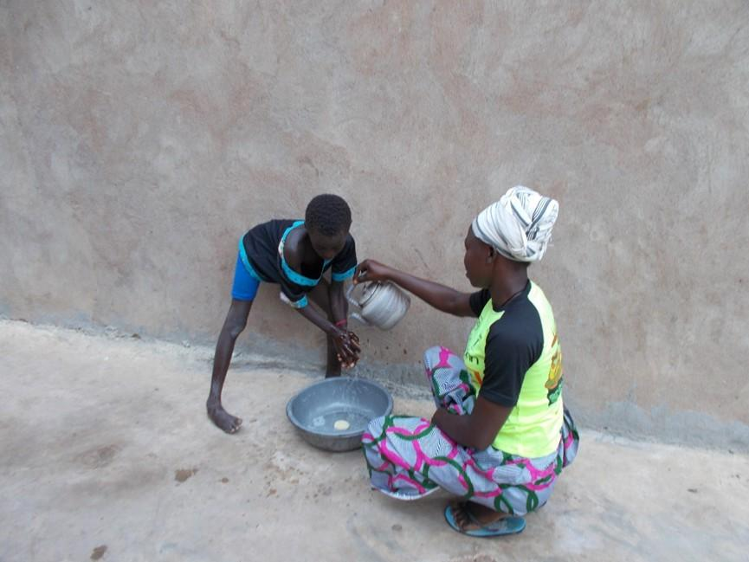

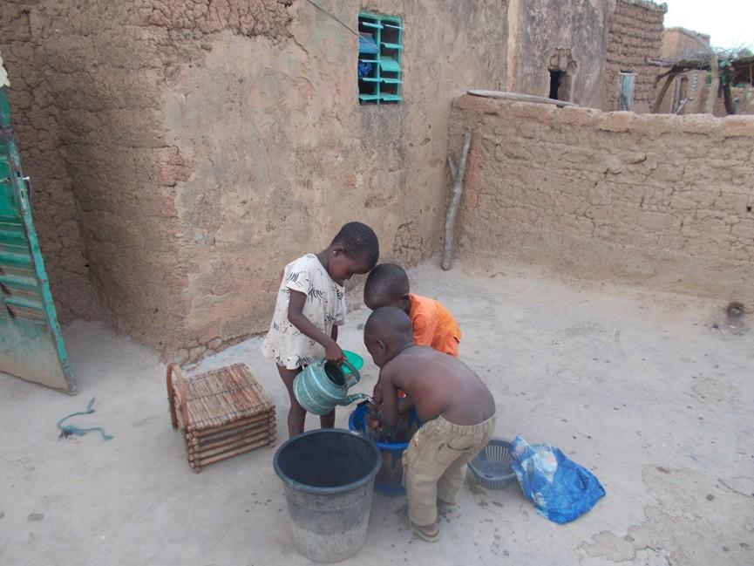

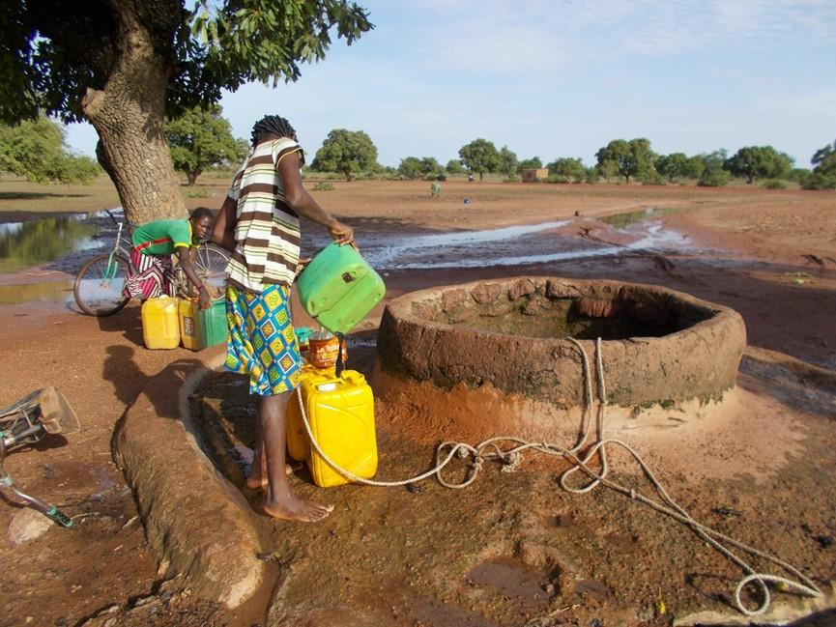

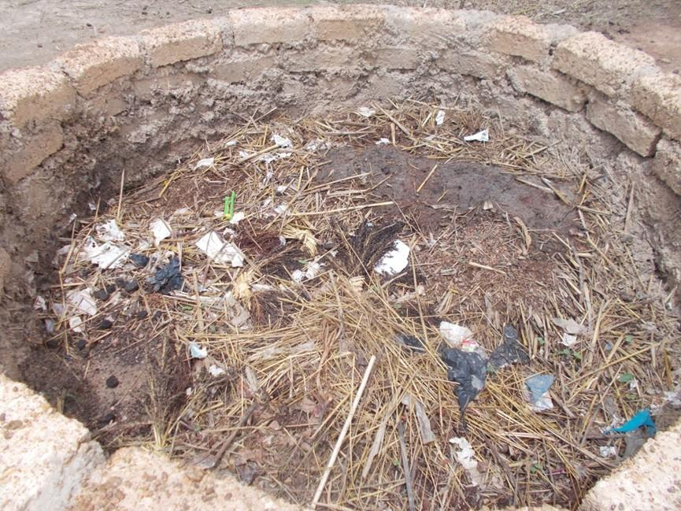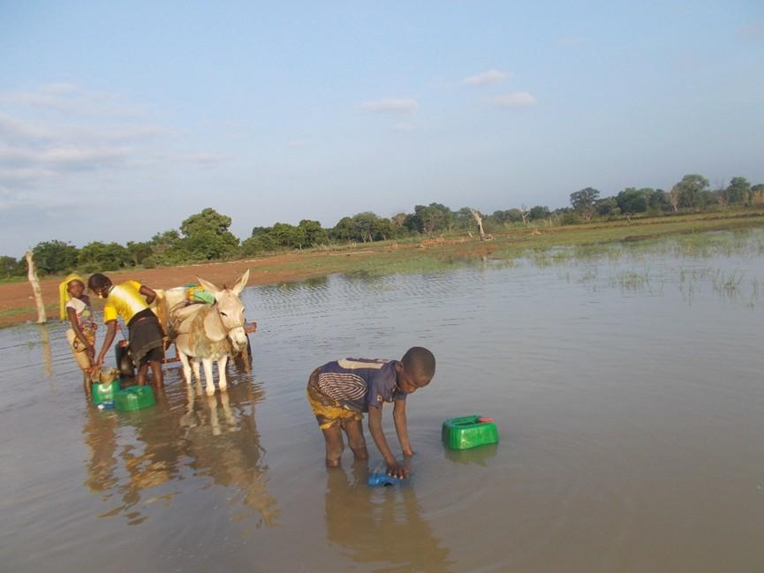

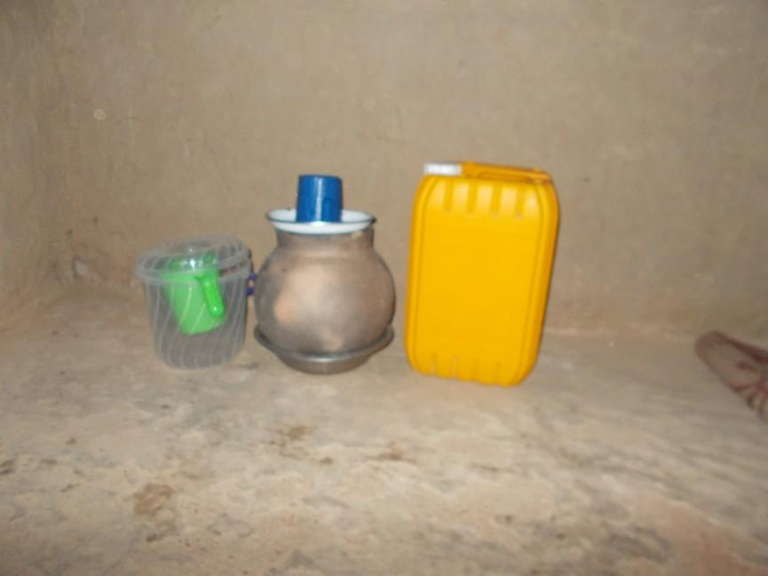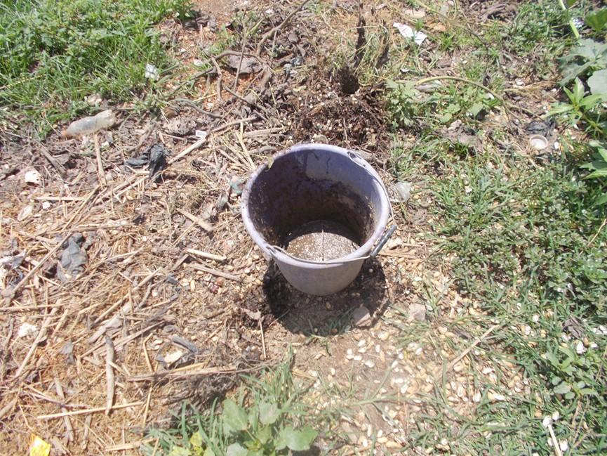

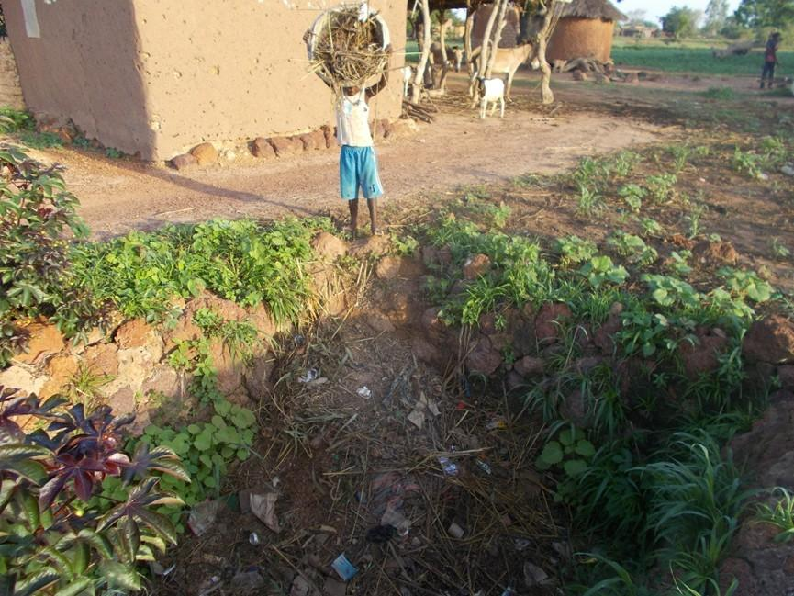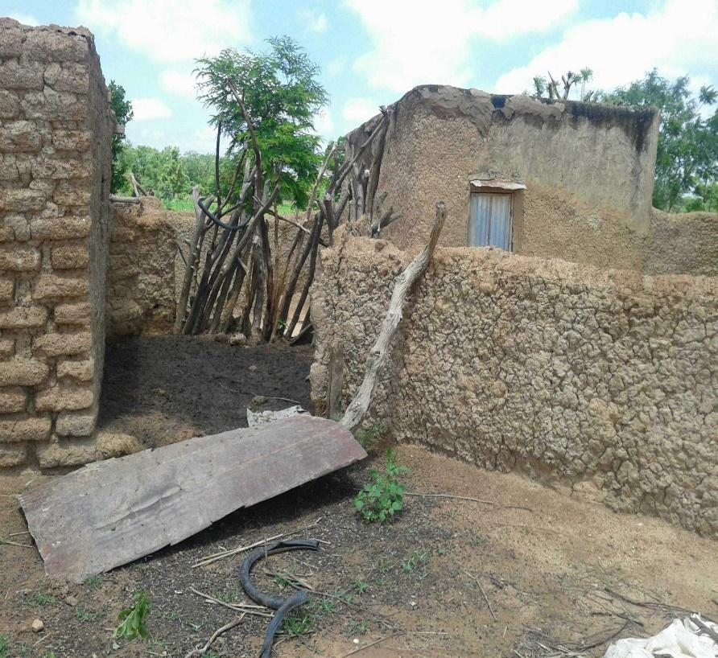

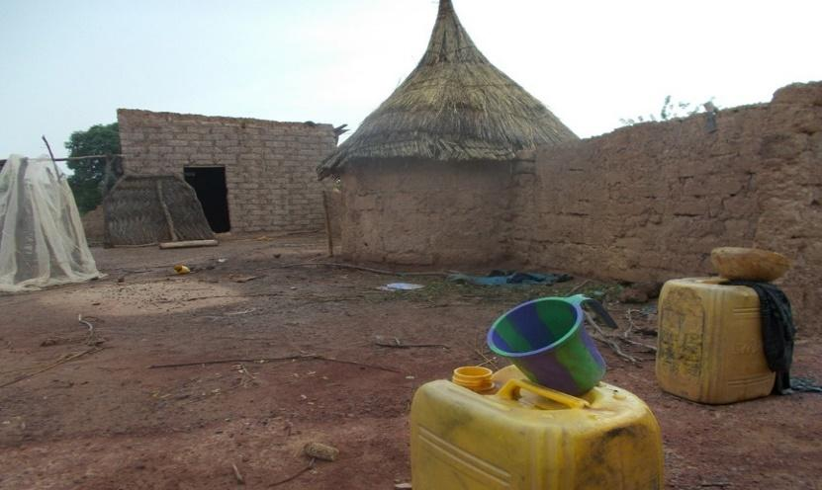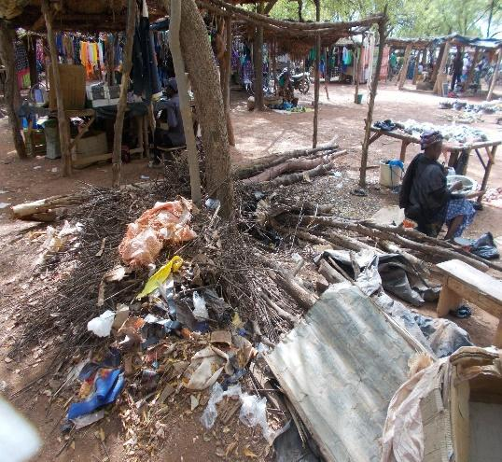

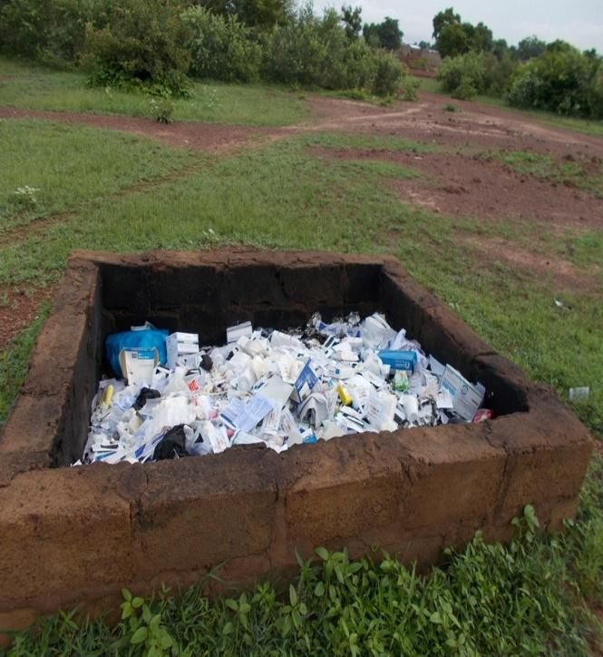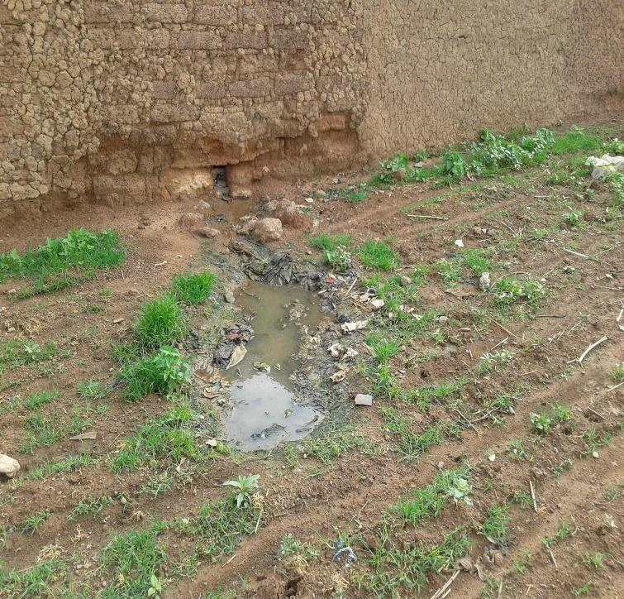

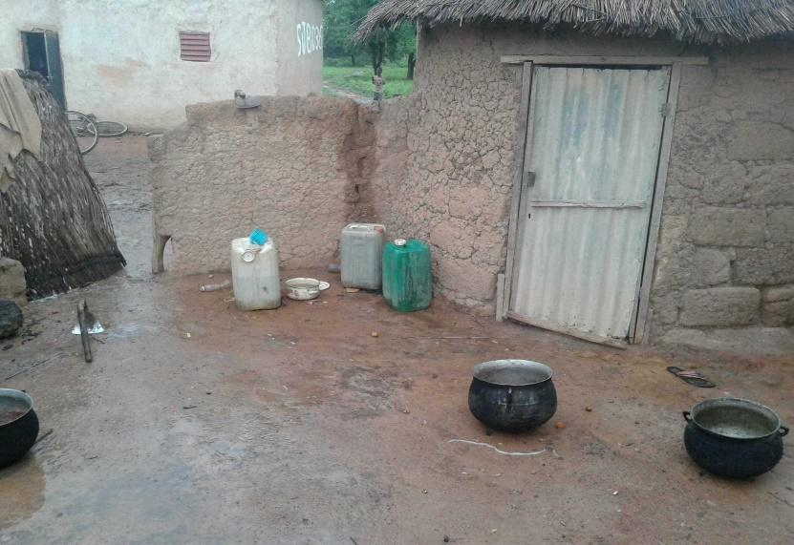

## Germs

Germs are tiny organisms that can cause disease. Germs are so small that we have to use a microscope to see them. The main types of germ are

**Bacteria**: These tiny, single-celled creatures can multiply (reproduce) outside the body or inside the body when they cause infections. Infections caused by bacteria include ear infections, sore throats (tonsillitis or angina), cavities and pneumonia.

Not all bacteria are bad. Some bacteria are good for our bodies. Good bacteria live in our intestines and help us to use the nutrients contained in the food we eat and to produce waste from what remains.

**Viruses**: Viruses need to be inside living cells to develop and reproduce. When viruses enter people's bodies, they can spread and make people ill. Viruses cause chickenpox, measles, flu and many other diseases.

**Fungi**: These are multi-cellular organisms (made up of many cells) that resemble plants. Unlike other plants, fungi cannot make their own food from the soil, water and air. Instead, fungi feed on plants, people and animals. They like to live in damp, warm places, and many fungi are harmless to healthy people.

**Protozoa**: These single-celled organisms like moisture and often spread disease through water. Some protozoa cause intestinal infections leading to diarrhoea, nausea and abdominal pain.

What do germs do? If germs invade our bodies, they take up nutrients and energy, and can produce toxins - proteins that act as poisons. These toxins can cause the symptoms of common infections, such as fever, colds, rashes, coughing, vomiting and diarrhoea.

By examining samples of blood, urine and other fluids under a microscope or sending them to a laboratory for further tests, doctors can determine which germs are living in your body and how they are making you ill.

To protect yourself from germs:

Wash your hands before eating or preparing food, after using the toilet, after touching animals, and after visiting a sick relative or friend. Use soap and water and rub your hands together for at least 20 seconds. Cover your nose and mouth when you sneeze and cover your mouth when you cough to avoid spreading germs. If you don't have a tissue, cough or sneeze into your elbow, NOT your hands.

## The immune system

The immune system is a complex network of tissues and organs, cells and proteins that work together to defend the body against infection, while protecting the body's own cells. Being immune means being protected. So it makes sense that the body system that helps fight disease is called the immune system.

The main parts of the immune system are:

white blood cells antibodies

the complement system the lymphatic system

the spleen

bone marrow thymus

White blood cells

White blood cells, also known as leukocytes, are the key players in your immune system. White blood cells include lymphocytes (such as B cells, T cells and natural killer cells), as well as many other types of immune cells.

There are two basic types of these germ-fighting cells:

**phagocytes**, which crush invading germs

**lymphocytes**, which enable the body to remember and recognise previous invaders.

Leukocytes are found in many places, including the spleen, an organ in the stomach that filters blood and helps fight infection. White blood cells can also be found in the bone marrow, a thick, spongy jelly inside the bones. White blood cells travel through the blood and tissues of your body, looking for foreign invaders (microbes) such as bacteria, viruses, parasites and fungi. When they find them, they launch an immune attack.

Antibodies

Antibodies help the body fight microbes or the toxins (poisons) they produce. To do this, they recognise substances called antigens on the surface of the microbes or in the chemicals they produce, which mark the microbe or toxin as foreign. The antibodies then mark these antigens to destroy them. Many cells, proteins and chemicals are involved in this attack.

The complement system

The complement system is made up of proteins whose actions complement the work carried out by antibodies.

Lymphatic system

The lymphatic system is a network of delicate tubes distributed throughout the body. The main roles of the lymphatic system are as follows: managing fluid levels in the body reacting to bacteria , treating cancer cells

treat cellular products that would otherwise lead to disease or disorders absorb some of the fats in our diet from the intestine.

The lymphatic system is made up of :

lymph nodes (also known as lymph glands) - which trap germs

lymphatic vessels - tubes that carry lymph, the colourless liquid that bathes your body's tissues and contains white blood cells that fight infection

white blood cells (lymphocytes). The spleen

The spleen is a blood filtering organ that eliminates microbes and destroys old or damaged red blood cells. It also manufactures the components of the immune system that fight disease (notably antibodies and lymphocytes).

Bone marrow

Bone marrow is the spongy tissue found inside bones. It produces the red blood cells our body needs to carry oxygen, the white blood cells we use to fight infection and the platelets we need to help our blood clot.

Thymus

The thymus filters and controls the contents of your blood. It produces white blood cells called "T lymphocytes".

The immune system keeps track of all the germs (microbes) it has already defeated so that it can recognise them and destroy them quickly if they re-enter the body.

Immune system abnormalities can lead to allergic diseases, immunodeficiency and autoimmune disorders.

The immune system keeps track of all the microbes it has defeated, in types of white blood cells (B and T lymphocytes) called memory cells. This means that it can quickly recognise and destroy the microbe if it enters the body again, before it can multiply and make you ill.

Some infections, such as colds and flu, need to be fought repeatedly, as many different viruses or strains of the same type of virus can cause these illnesses. Catching a cold or flu from one virus does not make you immune to others.

## Quiz: Antibiotic use

We are now going to discuss your thoughts and opinions about a certain type of medicine called antibiotics. (Explain what antibiotics are, show pictures, discuss local names).

1. My friends and family follow doctors' recommendations on the use of antibiotics.
2. Antibiotics are necessary for the common cold.
3. Antibiotics can have negative side effects
4. I would take antibiotics without consulting a doctor
5. In my community, it's common to use antibiotics without a prescription.
6. Antibiotics will be less effective in combating disease in the future
7. I keep any remaining or unused antibiotics or prescriptions.
8. I can easily get antibiotics on the market
9. I could easily get antibiotics from my family / a friend / a member of the household / the community.
10. When I'm sick enough to see my doctor, I expect a prescription for antibiotics.
11. I consult my doctor before taking antibiotics

Basic principles for effective communication

## COMMUNICATION

Communication is made up of (1) a communicator, (2) a message and (3) a receiver (Mersham & Skinner, 2007) and without these three elements, it cannot take place. The message can be both verbal (language, tone) and non-verbal (eye contact, body language, facial expressions) (Mersham & Skinner, 2007).

Effective listening is a major element of effective communication, as it will have an impact on how the message sent by the sender is interpreted, while showing that you are interested in what the customer is trying to express and that you respect them. Remember to treat the concerns of women and men in the same way.

Put personal concerns and stress aside when dealing with a customer.

be attentive and focused on the customer (don't look sleepy or bored)

Be open to the customer's communications while listening to them (this does not mean that you agree with them, but rather that you are prepared to listen).

Communicate attention through body language and facial expression (leaning forward, relaxed posture, making eye contact and nodding to indicate understanding).

Be aware of personal hang-ups when dealing with customers (you may have strong convictions on a certain subject, but being aware of them will enable you to control them when interacting with a customer).

Don't interrupt the customer and be sensitive to their difficulties. (Brems, 2001)

**Active listening techniques**: (based on (Brems, 2001))

Maintaining visual contact (eyes), with brief withdrawals of visual contact to absorb information (a demonstration of concentration such as breathing in, with the head tilted back).

Nodding

frowning, narrowing your eyes or pressing your lips together as a sign of concentration (not scepticism or doubt).

Discreet facilitating noises or phrases, such as "uh huh", "ah", "mmmmmm", "I see", "really" (like a silent statement of recognition or an expression of surprise).

Change your posture so that you can concentrate better, for example with your elbows on the desk and your hands clasped together.

Remain silent and still, leaving room for reflection and the formulation of ideas and responses.

It is also important to assess the patient:

(1) health literacy, (2) cultural understanding, (3) whether there are language barriers and (4) contextual factors, as these will play a part in how you respond to the customer (Brems, 2001). For example, if a client expresses that they are being abused by an intimate partner, you will need to respond with sensitivity and understanding. If there is a language barrier, you may need to use an interpreter or speak in very simple language at a very slow pace. You may be dealing with a customer who appears to be mentally ill or mentally unstable, and you will also need to take this into account in your response.

### Communicating clearly

According to Ratna (2019), the following guidelines should be followed to ensure clear communication:

*1) give a warm greeting, 2) maintain eye contact, 3) listen attentively, 4) be aware of the patient's body language as well as your own, 5) speak slowly and concretely in non-medical language, 6) use graphics and demonstrations when appropriate, and 7) encourage patient participation and questions. (Ratna, 2019)*

It is also suggested to use culturally appropriate analogies to aid customer understanding and to use a conversational style when addressing a customer, as this can make them feel more comfortable and relaxed (Ratna, 2019).

### Reacting with empathy

Empathy is our ability to put ourselves in another person's shoes and try to feel what they are temporarily feeling in order to respond from a position of understanding and warmth. It's about putting yourself in another person's shoes and trying to understand why others behave the way they do and what's behind that behaviour. A customer may be angry, but by practising empathy you can understand that they have been treated very badly by other pharmacists or health workers before. Once we understand the patient's message accurately, we will be able to adapt our treatment and communicate with warmth (Hugman, 2009).

| **Table 11.1 (Hugman, 2009) A compact version of how a healthcare professional might respond with empathy to what has been learned about this patient, distilled from what would be a much longer interaction.** | |
| --- | --- |
| "I am really sorry to hear that" | A genuine expression of concern |
| "It must have been a terrible time for you and your family". | Demonstrate empathy and understanding and recognise the patient's suffering. |
| "Operations can seem scary, especially when you have memories like that" | Acceptance of the patient's point of view and the validity of the reasons behind it. |
| "As hard as it is to accept, I think your situation is different." | Transition: letting go of bad experiences from the past; focusing on the new situation. In this case, feelings are respected and managed while a bridge to firmer, less emotional ground is built. |
| "You are young, healthy and strong and there are generally very few complications with this procedure". | Provide reasons why the current situation is different; focus on the positive aspects and the low risk; move the patient away from fear. |

| "I'd like you to meet the surgeon, listen to what he has to say and then make up your mind. | Transition: practical suggestion of a cautious, exploratory next step; reassurance that the patient remains in control; moving thoughts about the operation away from fantasy and back to reality - the person who would do the work. |
| --- | --- |
| "At the end of the day, you decide". | Confirmation that the patient is in control. |
| "What you have to weigh up is the very low risk of the operation against the likelihood that the condition (for example, perhaps a knee injury) will get worse in the future, and could be quite painful." | Contribution of professional judgement: frank presentation of the issues - risks and benefits - on which the patient must decide. |
| "Can we take this first step before you make your final decision?" | See permission tomove forward cautiously reaffirm the patient's freedom of choice |

### Steps to effective communication

1. **Paying attention**

Use the listening skills mentioned above to pay attention to what the customer is communicating.

Don't judge

Keep an open mind when listening to the customer and avoid passing judgement, as this is a barrier to communication and can turn the conversation into an argument.

Think

Paraphrase the information and emotions expressed so that the customer feels heard and that you are sure you understand them correctly. An example of this approach might be as follows:

"It sounds like you're very frustrated with ".

Clarify

Make sure you understand the message by asking questions:

"Let me get this straight... You can't afford to see a doctor at the moment and you're asking me to give you antibiotics without a prescription".

Summarise and react with empathy

Once the conversation has started, you will summarise what has been said to confirm that you have understood what has been said.

"What I'm hearing is. As much as I would love to help you right now, I can't prescribe any medication as I'm not a doctor. I would recommend that you go to your nearest clinic so that you can see a doctor and get the medical treatment you need. I know there are long queues at the clinic, but once you've seen the doctor, I'll be there.

**(According to Brems, 2001)**

## Negotiation

Through negotiation, two or more parties reach agreements by working together and managing conflict, rather than by arguing or withdrawing altogether (Greene & Burleson, 2003). All prejudices and personal pride must be set aside for the purposes of negotiation, as setting aside initial judgements allows a person to make more informed decisions based on logic. Furthermore, all information brought to the conversation should be verifiable, rather than personal opinions (Zohar, 2015). It is important to foster a spirit of trust between you and the client and emphasise that you are a healthcare worker and therefore will always act in the client's best interests.

During negotiations, you need to monitor your emotions and ensure that the dialogue is not emotionally charged, for example: "I've had enough of this customer, I'm sending him away". It is also known that positive emotions considerably increase the chances of resolving problems, so it is best to try to reduce tension if necessary and to be cooperative (Greene & Burleson, 2003). Efforts should be made to satisfy the interests of both parties by using problem-solving techniques (Zohar, 2015), for example by offering the other party alternative options and 'listening'. When negotiating with a customer, it is important not to attack the customer's position. When a customer feels less threatened, the risk of conflict decreases. It is important to make the customer feel "worthy" in the negotiation (Zohar, 2015).

Whatever the situation, decisions should always be consistent with good ethics and professionalism. If the customer tries to steer you away from these values, it is important to explain why they exist and what the implications are, if you decide to deviate from them (Zohar, 2015): 'As much as I would like to help you, I am not in a position to prescribe this medicine and if I do, I could not only lose my licence as a pharmacist but also potentially hurt you in the process by dispensing the wrong medicine'.

It has been found that skilled negotiators are more likely to obtain as much information as possible from their client and that when they disagree, they do so by explaining their concerns rather than immediately expressing their disagreement (Greene & Burleson, 2003), for example, they might say

"**What worries me in this situation is that I'm giving you the wrong medicine for your condition and you're getting sick**" rather than "No, I can't do that!

Never rush the negotiation process and allow time for silences. Bear in mind that negotiations are largely based on communication, so it is important to use the skills in the section above to achieve a desirable outcome for all parties (Greene & Burleson, 2003). The customer should not feel that they are "wasting their time" (Zohar, 2015) as a successful negotiation is always a joint win, which should be emphasised throughout the discussion (Greene & Burleson, 2003).

### communication and negotiation

<https://www.verywellmind.com/understand-body-language-and-facial-expressions-4147228>

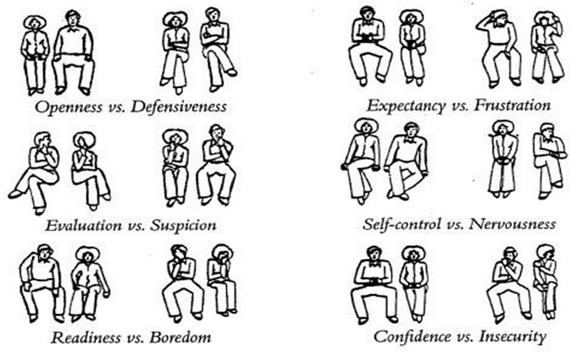

**Accessible body language**: openness versus defensiveness, expectation versus frustration, evaluation versus suspicion, self-control versus nervousness, eagerness versus boredom, confidence versus insecurity

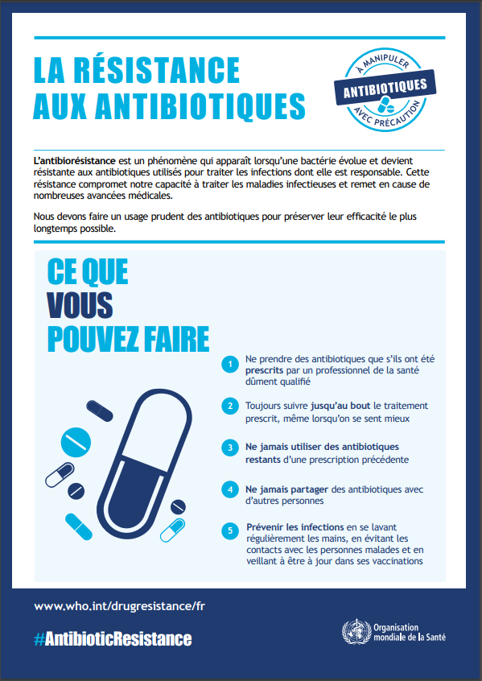

## Monitoring and evaluation form - CABU-EICO

| **Village** |  |
| --- | --- |
| **Tour number (1/2/3)** |  |

| **Communication around/announcement of the operation?** | |
| --- | --- |
| The information provided for the event: was it clear and legible? Was it sufficient? |  |
| **What was your overall impression of how the implementation went?** | |
|  | |
| **Notes for next time?** | |
|  | |

| **Date and day number (1/2/3)** |  |
| --- | --- |
| **Researcher(s)** |  |
| **Name of activity**  Was it carried out in the order specified in the manual? Changes? |  |
| **Location (accessible?** adapted**)** |  |
| **How much (approx.):**  Men Women  Teenagers and children  Or others? |  |
| **Audience (engaged? Distracted? Questions asked?**  **Expressed something striking? )** |  |
| **Equipment used (adapted?)** |  |
| **Any important points you noted/observed (went well/not so well?). Any notes?** |  |

## ACCESS Antibiotics:

This group includes antibiotics that have activity against a wide range of commonly encountered susceptible pathogens while having a lower potential for resistance than antibiotics in other groups. Antibiotics in the Selected Access Group are recommended as essential first or second choice empirical treatment options for infectious syndromes reviewed by the EML Expert Committee and are included as individual medicines on model essential medicines lists to improve access and promote appropriate use.

| Antibiotic | Class | ATC code | Category | Listed on EML  2021 |
| --- | --- | --- | --- | --- |
| Amikacin | Aminoglycosides | J01GB06 | Access | Yes |
| Amoxicillin | Penicillins | J01CA04 | Access | Yes |
| Amoxicillin/clavulanic- acid | Beta-lactam/beta-lactamase- inhibitor | J01CR02 | Access | Yes |
| Ampicillin | Penicillins | J01CA01 | Access | Yes |
| Ampicillin/sulbactam | Beta-lactam/beta-lactamase- inhibitor | J01CR01 | Access | No |
| Azidocillin | Penicillins | J01CE04 | Access | No |

| Bacampicillin | Penicillins | J01CA06 | Access | No |
| --- | --- | --- | --- | --- |
| Benzathine-benzylpen icillin | Penicillins | J01CE08 | Access | Yes |
| Benzylpenicillin | Penicillins | J01CE01 | Access | Yes |
| Brodimoprim | Trimethoprim-derivatives | J01EA02 | Access | No |
| Cefacetrile | First-generation-cephalospor ins | J01DB10 | Access | No |
| Cefadroxil | First-generation-cephalospor ins | J01DB05 | Access | No |
| Cefalexin | First-generation-cephalospor ins | J01DB01 | Access | Yes |
| Cefaloridine | First-generation-cephalospor ins | J01DB02 | Access | No |
| Cefalotin | First-generation-cephalospor ins | J01DB03 | Access | No |
| Cefapirin | First-generation-cephalospor ins | J01DB08 | Access | No |
| Cefatrizine | First-generation-cephalospor ins | J01DB07 | Access | No |
| Cefazedone | First-generation-cephalospor ins | J01DB06 | Access | No |
| Cefazolin | First-generation-cephalospor | J01DB04 | Access | Yes |

|  | ins |  |  |  |
| --- | --- | --- | --- | --- |
| Cefradine | First-generation-cephalospor ins | J01DB09 | Access | No |
| Cefroxadine | First-generation-cephalospor ins | J01DB11 | Access | No |
| Ceftezole | First-generation-cephalospor ins | J01DB12 | Access | No |
| Chloramphenicol | Amphenicols | J01BA01 | Access | Yes |
| Clindamycin | Lincosamides | J01FF01 | Access | Yes |
| Clometocillin | Penicillins | J01CE07 | Access | No |
| Cloxacillin | Penicillins | J01CF02 | Access | Yes |
| Dicloxacillin | Penicillins | J01CF01 | Access | No |
| Doxycycline | Tetracyclines | J01AA02 | Access | Yes |
| Epicillin | Penicillins | J01CA07 | Access | No |
| Flucloxacillin | Penicillins | J01CF05 | Access | No |
| Furazidin | Nitrofuran derivatives | J01XE03 | Access | No |
| Gentamicin | Aminoglycosides | J01GB03 | Access | Yes |
| Hetacillin | Penicillins | J01CA18 | Access | No |
| Mecillinam | Penicillins | J01CA11 | Access | No |

| Metampicillin | Penicillins | J01CA14 | Access | No |
| --- | --- | --- | --- | --- |
| Meticillin | Penicillins | J01CF03 | Access | No |
| Metronidazole_IV | Imidazoles | J01XD01 | Access | Yes |
| Metronidazole_oral | Imidazoles | P01AB01 | Access | Yes |
| Nafcillin | Penicillins | J01CF06 | Access | No |
| Nifurtoinol | Nitrofuran derivatives | J01XE02 | Access | No |
| Nitrofurantoin | Nitrofuran-derivatives | J01XE01 | Access | Yes |
| Ornidazole_IV | Imidazoles | J01XD03 | Access | No |
| Ornidazole_oral | Imidazoles | P01AB03 | Access | No |
| Oxacillin | Penicillins | J01CF04 | Access | No |
| Penamecillin | Penicillins | J01CE06 | Access | No |
| Phenoxymethylpenicill in | Penicillins | J01CE02 | Access | Yes |
| Pivampicillin | Penicillins | J01CA02 | Access | No |
| Pivmecillinam | Penicillins | J01CA08 | Access | No |
| Procaine-benzylpenicil lin | Penicillins | J01CE09 | Access | Yes |
| Propicillin | Penicillins | J01CE03 | Access | No |
| Secnidazole | Imidazoles | P01AB07 | Access | No |

| Spectinomycin | Aminocyclitols | J01XX04 | Access | Yes |
| --- | --- | --- | --- | --- |
| Sulbactam | Beta-lactamase-inhibitors | J01CG01 | Access | No |
| Sulfadiazine | Sulfonamides | J01EC02 | Access | No |
| Sulfadiazine/tetroxopr im | Sulfonamide-trimethoprim-c ombinations | J01EE06 | Access | No |
| Sulfadiazine/trimetho prim | Sulfonamide-trimethoprim-c ombinations | J01EE02 | Access | No |
| Sulfadimethoxine | Sulfonamides | J01ED01 | Access | No |
| Sulfadimidine | Sulfonamides | J01EB03 | Access | No |
| Sulfadimidine/trimeth oprim | Sulfonamide-trimethoprim-c ombinations | J01EE05 | Access | No |
| Sulfafurazole | Sulfonamides | J01EB05 | Access | No |
| Sulfaisodimidine | Sulfonamides | J01EB01 | Access | No |
| Sulfalene | Sulfonamides | J01ED02 | Access | No |
| Sulfamazone | Sulfonamides | J01ED09 | Access | No |
| Sulfamerazine | Sulfonamides | J01ED07 | Access | No |
| Sulfamerazine/trimeth oprim | Sulfonamide-trimethoprim-c ombinations | J01EE07 | Access | No |
| Sulfamethizole | Sulfonamides | J01EB02 | Access | No |
| Sulfamethoxazole | Sulfonamides | J01EC01 | Access | No |

| Sulfamethoxazole/tri  methoprim | Sulfonamide-trimethoprim-c  ombinations | J01EE01 | Access | Yes |
| --- | --- | --- | --- | --- |
| Sulfamethoxypyridazi ne | Sulfonamides | J01ED05 | Access | No |
| Sulfametomidine | Sulfonamides | J01ED03 | Access | No |
| Sulfametoxydiazine | Sulfonamides | J01ED04 | Access | No |
| Sulfametrole/trimetho prim | Sulfonamide-trimethoprim-c ombinations | J01EE03 | Access | No |
| Sulfamoxole | Sulfonamides | J01EC03 | Access | No |
| Sulfamoxole/trimetho prim | Sulfonamide-trimethoprim-c ombinations | J01EE04 | Access | No |
| Sulfanilamide | Sulfonamides | J01EB06 | Access | No |
| Sulfaperin | Sulfonamides | J01ED06 | Access | No |
| Sulfaphenazole | Sulfonamides | J01ED08 | Access | No |
| Sulfapyridine | Sulfonamides | J01EB04 | Access | No |
| Sulfathiazole | Sulfonamides | J01EB07 | Access | No |
| Sulfathiourea | Sulfonamides | J01EB08 | Access | No |
| Sultamicillin | Beta-lactam/beta-lactamase- inhibitor | J01CR04 | Access | No |
| Talampicillin | Penicillins | J01CA15 | Access | No |

| Tetracycline | Tetracyclines | J01AA07 | Access | No |
| --- | --- | --- | --- | --- |
| Thiamphenicol | Amphenicols | J01BA02 | Access | No |
| Tinidazole_IV | Imidazoles | J01XD02 | Access | No |
| Tinidazole_oral | Imidazoles | P01AB02 | Access | No |
| Trimethoprim | Trimethoprim-derivatives | J01EA01 | Access | Yes |

## WATCH group Antibiotics:

This group includes antibiotic classes with a higher potential for resistance and includes most of the highest priority agents among the critically important antimicrobials for human medicine1 and/or antibiotics with a relatively high risk of selection for bacterial resistance. These drugs should be considered as priority targets for stewardship and surveillance programmes. Some Watch Group antibiotics are recommended as first or second choice empirical treatment options for a limited number of specific infectious syndromes and are included as individual medicines on the WHO Model Lists of Essential Medicines.

[1 Critically Important Antimicrobials for Human Medicine 6th Revision 2018](https://apps.who.int/iris/bitstream/handle/10665/312266/9789241515528-eng.pdf?ua=1)

| Antibiotic | Class | ATC code | Category | Listed on EML  2021 |
| --- | --- | --- | --- | --- |
| Arbekacin | Aminoglycosides | J01GB12 | Watch | No |
| Aspoxicillin | Penicillins | J01CA19 | Watch | No |
| Azithromycin | Macrolides | J01FA10 | Watch | Yes |
| Azlocillin | Penicillins | J01CA09 | Watch | No |
| Bekanamycin | Aminoglycosides | J01GB13 | Watch | No |
| Biapenem | Carbapenems | J01DH05 | Watch | No |

| Carbenicillin | Penicillins | J01CA03 | Watch | No |
| --- | --- | --- | --- | --- |
| Carindacillin | Penicillins | J01CA05 | Watch | No |
| Cefaclor | Second-generation-cephalosp orins | J01DC04 | Watch | No |
| Cefamandole | Second-generation-cephalosp orins | J01DC03 | Watch | No |
| Cefbuperazone | Second-generation-cephalosp orins | J01DC13 | Watch | No |
| Cefcapene-pivoxil | Third-generation-cephalospor ins | J01DD17 | Watch | No |
| Cefdinir | Third-generation-cephalospor ins | J01DD15 | Watch | No |
| Cefditoren-pivoxil | Third-generation-cephalospor ins | J01DD16 | Watch | No |
| Cefepime | Fourth-generation-cephalosp orins | J01DE01 | Watch | No |
| Cefetamet-pivoxil | Third-generation-cephalospor ins | J01DD10 | Watch | No |
| Cefixime | Third-generation-cephalospor ins | J01DD08 | Watch | Yes |
| Cefmenoxime | Third-generation-cephalospor ins | J01DD05 | Watch | No |

| Cefmetazole | Second-generation-cephalosp  orins | J01DC09 | Watch | No |
| --- | --- | --- | --- | --- |
| Cefminox | Second-generation-cephalosp orins | J01DC12 | Watch | No |
| Cefodizime | Third-generation-cephalospor ins | J01DD09 | Watch | No |
| Cefonicid | Second-generation-cephalosp orins | J01DC06 | Watch | No |
| Cefoperazone | Third-generation-cephalospor ins | J01DD12 | Watch | No |
| Ceforanide | Second-generation-cephalosp orins | J01DC11 | Watch | No |
| Cefoselis | Fourth-generation-cephalosp orins | to be assigned | Watch | No |
| Cefotaxime | Third-generation-cephalospor ins | J01DD01 | Watch | Yes |
| Cefotetan | Second-generation-cephalosp orins | J01DC05 | Watch | No |
| Cefotiam | Second-generation-cephalosp orins | J01DC07 | Watch | No |
| Cefoxitin | Second-generation-cephalosp orins | J01DC01 | Watch | No |
| Cefozopran | Fourth-generation-cephalosp | J01DE03 | Watch | No |

|  | orins |  |  |  |
| --- | --- | --- | --- | --- |
| Cefpiramide | Third-generation-cephalospor ins | J01DD11 | Watch | No |
| Cefpirome | Fourth-generation-cephalosp orins | J01DE02 | Watch | No |
| Cefpodoxime-proxe til | Third-generation-cephalospor ins | J01DD13 | Watch | No |
| Cefprozil | Second-generation-cephalosp orins | J01DC10 | Watch | No |
| Cefsulodin | Third-generation-cephalospor ins | J01DD03 | Watch | No |
| Ceftazidime | Third-generation-cephalospor ins | J01DD02 | Watch | Yes |
| Cefteram-pivoxil | Third-generation-cephalospor ins | J01DD18 | Watch | No |
| Ceftibuten | Third-generation-cephalospor ins | J01DD14 | Watch | No |
| Ceftizoxime | Third-generation-cephalospor ins | J01DD07 | Watch | No |
| Ceftriaxone | Third-generation-cephalospor ins | J01DD04 | Watch | Yes |
| Cefuroxime | Second-generation-cephalosp orins | J01DC02 | Watch | Yes |

| Chlortetracycline | Tetracyclines | J01AA03 | Watch | No |
| --- | --- | --- | --- | --- |
| Cinoxacin | Quinolones | J01MB06 | Watch | No |
| **Ciprofloxacin** | **Fluoroquinolones** | **J01MA02** | **Watch** | **Yes** |
| Clarithromycin | Macrolides | J01FA09 | Watch | Yes |
| Clofoctol | Phenol derivatives | J01XX03 | Watch | No |
| Clomocycline | Tetracyclines | J01AA11 | Watch | No |
| Delafloxacin | Fluoroquinolones | J01MA23 | Watch | No |
| Demeclocycline | Tetracyclines | J01AA01 | Watch | No |
| Dibekacin | Aminoglycosides | J01GB09 | Watch | No |
| Dirithromycin | Macrolides | J01FA13 | Watch | No |
| Doripenem | Carbapenems | J01DH04 | Watch | No |
| Enoxacin | Fluoroquinolones | J01MA04 | Watch | No |
| Ertapenem | Carbapenems | J01DH03 | Watch | No |
| Erythromycin | Macrolides | J01FA01 | Watch | No |
| Fidaxomicin | Macrolides | A07AA12 | Watch | No |
| Fleroxacin | Fluoroquinolones | J01MA08 | Watch | No |
| Flomoxef | Second-generation-cephalosp orins | J01DC14 | Watch | No |
| Flumequine | Quinolones | J01MB07 | Watch | No |

| Flurithromycin | Macrolides | J01FA14 | Watch | No |
| --- | --- | --- | --- | --- |
| Fosfomycin_oral | Phosphonics | J01XX01 | Watch | No |
| Fusidic-acid | Steroid antibacterials | J01XC01 | Watch | No |
| Garenoxacin | Fluoroquinolones | J01MA19 | Watch | No |
| Gatifloxacin | Fluoroquinolones | J01MA16 | Watch | No |
| Gemifloxacin | Fluoroquinolones | J01MA15 | Watch | No |
| Grepafloxacin | Fluoroquinolones | J01MA11 | Watch | No |
| Imipenem/cilastati n | Carbapenems | J01DH51 | Watch | No |
| Isepamicin | Aminoglycosides | J01GB11 | Watch | No |
| Josamycin | Macrolides | J01FA07 | Watch | No |
| Kanamycin_IV | Aminoglycosides | J01GB04 | Watch | No |
| Kanamycin_oral | Aminoglycosides | A07AA08 | Watch | No |
| Lascufloxacin | Fluoroquinolones | J01MA25 | Watch | No |
| Latamoxef | Third-generation-cephalospor ins | J01DD06 | Watch | No |
| Levofloxacin | Fluoroquinolones | J01MA12 | Watch | No |
| Levonadifloxacin | Fluoroquinolones | J01MA24 | Watch | No |
| Lincomycin | Lincosamides | J01FF02 | Watch | No |

| Lomefloxacin | Fluoroquinolones | J01MA07 | Watch | No |
| --- | --- | --- | --- | --- |
| Loracarbef | Second-generation-cephalosp orins | J01DC08 | Watch | No |
| Lymecycline | Tetracyclines | J01AA04 | Watch | No |
| Meropenem | Carbapenems | J01DH02 | Watch | Yes |
| Metacycline | Tetracyclines | J01AA05 | Watch | No |
| Mezlocillin | Penicillins | J01CA10 | Watch | No |
| Micronomicin | Aminoglycosides | to be assigned | Watch | No |
| Midecamycin | Macrolides | J01FA03 | Watch | No |
| Minocycline_oral | Tetracyclines | J01AA08 | Watch | No |
| Miocamycin | Macrolides | J01FA11 | Watch | No |
| Moxifloxacin | Fluoroquinolones | J01MA14 | Watch | No |
| Nemonoxacin | Quinolones | J01MB08 | Watch | No |
| Neomycin_IV | Aminoglycosides | J01GB05 | Watch | No |
| Neomycin_oral | Aminoglycosides | A07AA01 | Watch | No |
| Netilmicin | Aminoglycosides | J01GB07 | Watch | No |
| Norfloxacin | Fluoroquinolones | J01MA06 | Watch | No |
| Ofloxacin | Fluoroquinolones | J01MA01 | Watch | No |

| Oleandomycin | Macrolides | J01FA05 | Watch | No |
| --- | --- | --- | --- | --- |
| Oxolinic-acid | Quinolones | J01MB05 | Watch | No |
| Oxytetracycline | Tetracyclines | J01AA06 | Watch | No |
| Panipenem | Carbapenems | J01DH55 | Watch | No |
| Pazufloxacin | Fluoroquinolones | J01MA18 | Watch | No |
| Pefloxacin | Fluoroquinolones | J01MA03 | Watch | No |
| Penimepicycline | Tetracyclines | J01AA10 | Watch | No |
| Pheneticillin | Penicillins | J01CE05 | Watch | No |
| Pipemidic-acid | Quinolones | J01MB04 | Watch | No |
| Piperacillin | Penicillins | J01CA12 | Watch | No |
| Piperacillin/tazobac tam | Beta-lactam/beta-lactamase-i nhibitor_anti-pseudomonal | J01CR05 | Watch | Yes |
| Piromidic-acid | Quinolones | J01MB03 | Watch | No |
| Pristinamycin | Streptogramins | J01FG01 | Watch | No |
| Prulifloxacin | Fluoroquinolones | J01MA17 | Watch | No |
| Ribostamycin | Aminoglycosides | J01GB10 | Watch | No |
| Rifabutin | Rifamycins | J04AB04 | Watch | No |
| Rifampicin | Rifamycins | J04AB02 | Watch | No |
| Rifamycin_IV | Rifamycins | J04AB03 | Watch | No |

| Rifamycin_oral | Rifamycins | A07AA13 | Watch | No |
| --- | --- | --- | --- | --- |
| Rifaximin | Rifamycins | A07AA11 | Watch | No |
| Rokitamycin | Macrolides | J01FA12 | Watch | No |
| Rolitetracycline | Tetracyclines | J01AA09 | Watch | No |
| Rosoxacin | Quinolones | J01MB01 | Watch | No |
| Roxithromycin | Macrolides | J01FA06 | Watch | No |
| Rufloxacin | Fluoroquinolones | J01MA10 | Watch | No |
| Sarecycline | Tetracyclines | J01AA14 | Watch | No |
| Sisomicin | Aminoglycosides | J01GB08 | Watch | No |
| Sitafloxacin | Fluoroquinolones | J01MA21 | Watch | No |
| Solithromycin | Macrolides | J01FA16 | Watch | No |
| Sparfloxacin | Fluoroquinolones | J01MA09 | Watch | No |
| Spiramycin | Macrolides | J01FA02 | Watch | No |
| Streptoduocin | Aminoglycosides | J01GA02 | Watch | No |
| Streptomycin_IV | Aminoglycosides | J01GA01 | Watch | No |
| Streptomycin_oral | Aminoglycosides | A07AA04 | Watch | No |
| Sulbenicillin | Penicillins | J01CA16 | Watch | No |
| Tazobactam | Beta-lactamase-inhibitors | J01CG02 | Watch | No |

| Tebipenem | Carbapenems | J01DH06 | Watch | No |
| --- | --- | --- | --- | --- |
| Teicoplanin | Glycopeptides | J01XA02 | Watch | No |
| Telithromycin | Macrolides | J01FA15 | Watch | No |
| Temafloxacin | Fluoroquinolones | J01MA05 | Watch | No |
| Temocillin | Penicillins | J01CA17 | Watch | No |
| Ticarcillin | Penicillins | J01CA13 | Watch | No |
| Tobramycin | Aminoglycosides | J01GB01 | Watch | No |
| Tosufloxacin | Fluoroquinolones | J01MA22 | Watch | No |
| Troleandomycin | Macrolides | J01FA08 | Watch | No |
| Trovafloxacin | Fluoroquinolones | J01MA13 | Watch | No |
| Vancomycin_IV | Glycopeptides | J01XA01 | Watch | Yes |
| Vancomycin_oral | Glycopeptides | A07AA09 | Watch | Yes |

## Activity table with the different categories of the population

| Target group | Members of the community | Members of the community | Formal healthcare professionals and drug sellers  informal/community members | Members of the community,  formal health professionals, drug sellers  informal |
| --- | --- | --- | --- | --- |
| **Functions**  **Activities** | Generate  social capital, social support and community involvement | Developing knowledge about hygiene and hand washing | Developing knowledge about antibiotics  (bacteria/viruses) | Co-developing changes to  behaviour  hygiene, hand washing and antibiotics |
| **First round activities: Day 1** | | | | |
| Inform village leaders (chief, ic, cvd, asbc, youth leaders),  women, associations, iman, catechist etc) | X | X | X | X |

| Inform the heads of the village's schools (remind them of  that an activity will be carried out with the pupils on the  Wednesday mornings) | X | X | X | X |
| --- | --- | --- | --- | --- |
| Invitation to the Community event (to be held in the evening) by door-to-door canvassing | X | X |  | X |
| Face-to-face meetings with informal sellers, to tell them about the activity that will be  orgnised with them; discussing with them the cases they  discuss the main difficulties and talk about future training and agree on the venue |  |  | X | X |
| Face-to-face sessions with formal health workers; discuss with them the cases they are getting for  which they prescribe antibiotics |  |  | X | X |

| Training session with pharmacists, sales staff and health workers: explain the purpose of the training;  establish ground rules for the sessions; discussion quiz on the immune system; discuss bacteria and viruses;  take out a bag containing a range of antibiotics that  are usually sold on the marches and starts a discussion about these antibiotics |  |  | X | X |
| --- | --- | --- | --- | --- |
| Event  Plan **A** community event: podium to announce the event 1 hour beforehand; installation of guests; declaration and support from the  the village chief/representative who  programme on hand washing with soap/ash and RAM; projection of animations/videos  youtube; installation of  theatre props on both neighbours;  the giant clock on | X | X |  | X |

| disgusting character discusses his routine  the gentle person by washing his or her hands; discuss the role that each person plays in the health of his or her community.  community (washing hands, taking medication  properly);  commitment ceremony; distributing soap to people who have been  commitment and  distribution of certificates, ask participants to install a hand-washing facility in each  concession. |  |  |  |  |
| --- | --- | --- | --- | --- |
| Plan **B** community event: podium  to announce the event 1 hour beforehand;  install the guests;  declaration and support of the  village that unfolds the  programme on hand washing with soap/ash | X | X |  | X |

| and RAM; choose **09**  photos of the project  photovoice and initiate discussions on each  photo (do they see similar things in their  community? Is it a  problems? What are the problems? What are the solutions? the giant clock the disgusting character  discusses his routine  the gentle person by washing his or her hands; discuss the role that each person plays in the health of his or her community.  community (washing hands, taking medication  properly);  commitment ceremony; distributing soap to people who have been  commitment and  distribution of certificates, ask participants to install a hand-washing facility in each  concession. |  |  |  |  |
| --- | --- | --- | --- | --- |

| Fill in the monitoring and evaluation form |  | X | X | X |
| --- | --- | --- | --- | --- |
| **First round activities: Day 2** | | | | |
| Face-to-face meetings with informal sellers, to tell them about the activity that will be  orgnised with them; discussing with them the cases they  discuss the main difficulties and talk about future training and agree on the location; talk to them about treating diarrhoea in children.  infant |  |  | X | X |
| Training session with occupational health workers  health centre; their  remind them of the day's activities; discuss with them the cases they receive for which antibiotics need to be prescribed;  ask what the main difficulties are; talk to them about treating infant diarrhoea |  |  | X | X |

| Training session with pharmacists, sales staff, health workers: (2nd  session). Ask participants to name the challenges they have faced since the  last session; ask them to ask questions  questions at yesterday's session; to tell them  that today we will be discussing  antibiotics; discussion in pairs (approx. 5 mins) followed by a group discussion (10 mins) of their  perception of  antibiotics; quiz on  antibiotics; discuss childhood diarrhoea; form pairs and each pair of children  pair discusses the  frequency with which people buy antibiotics linked to the  childhood diarrhoea; discuss clinical algorithms for diarrhoea for all ages |  |  | X | X |
| --- | --- | --- | --- | --- |

| Ad hoc meetings (short sessions: 10mins) with men and women (walk the streets looking for those who want to discuss in private)  showing animated films on a  computer) and lead discussions around these videos  Or choose photos from the project  photovoice and chat with them.  They are therefore invited to  make commitments and receive a certificate and soap. | X | X |  | X |
| --- | --- | --- | --- | --- |
| Animation podium;  music as the guests settle in.  Raising awareness of household waste management with photos of the project  photovoice on the causes, consequences and  behaviour change | X | X |  | X |

| Educational talks on the issue of household water conservation | X | X |  | X |
| --- | --- | --- | --- | --- |
| Fill in the monitoring and evaluation form | X | X | X | X |
| **First round activities: Day 3** | | | | |
| Visiting informal drug sellers;  discuss individual cases of drug sales and what they need to do; the questions that people  how to answer these questions; talk about bronchitis; remind them of the training they need. |  |  | X | X |
| Visit health workers at the health centre; discuss cases with them  for which it is necessary to prescribe  antibiotics; asking what the main difficulties are; talking about  bronchitis; taking them upstairs  **treatment guides** |  |  | X | X |

| School event:  theatre at the tug-of-war competition | X | X |  | X |
| --- | --- | --- | --- | --- |
| Discussion with the children/pupils on the  hand washing with soap/ash, diseases and antibiotics |  |  |  |  |
| The giant clock: the  actors explain their daily routines (the  good character has a clean routine with lots of washing of  hands; on the other hand  disguised character goes through a disgusting routine without washing his hands at all);  discussion with pupils on everyday actions involving washing hands with soap and/or ash; commitment  slogans; a hand-washing station installed in the schools and is used by all pupils.  supervised by students chosen by teachers | X | X |  | X |

| Animation podium; speeches by the village chief or representative the consequences of non  hand washing;  projection of films on hand washing, on the  RAM; raising awareness of hand washing at  soap/ash: causes, consequences and  change of  behaviour, while at the same time encouraging people to think about antibiotics;  to raise awareness of the problem of  antibiotic resistance | X | X |  | X |
| --- | --- | --- | --- | --- |
| Fill in the monitoring and evaluation form | X | X | X | X |
| **Second round activities: Day 1** | | | | |
| Inform the village leaders of the activities to be carried out in the locality on that day (chief, ic, cvd, asbc, youth leaders, women leaders), | X | X | X | X |

| associations, iman, catechist etc) |  |  |  |  |
| --- | --- | --- | --- | --- |
| Cleaning of dirty areas and more  frequented by the public and the decision to organise clean-up days;  hand-washing station with soap after cleaning;  ask those in positions of responsibility to introduce an annual cleanliness day | X | X |  | X |
| Greeting sales staff  and remind them of what needs to be done  today; discuss with them the cases that they have  the main difficulties and discuss them with them; talk to them about  skin and soft tissue infections, and  antibiotics; remind them of the training |  |  | X | X |
| Pharmacy visit  planned: discuss with them the cases they get when they prescribe |  |  | X | X |

| antibiotics; discuss how they are prescribed, any concerns or worries they may have  about skin and soft tissue infections and antibiotics; their  show **treatment guides** |  |  |  |  |
| --- | --- | --- | --- | --- |
| ATPC activity: on the  mapping of defecation areas | X | X |  | X |
| **Second round activities: Day 2** | | | | |
| Greeting sales staff  and remind them of the day's activity; ask for the cases they get;  tell them about the fever  unexplained (with or without malaria) and  antibiotics; remind them of the training | X | X | X | X |
| Pharmacy visits  the cases they obtain; and to make sure that they  talk about fever |  |  | X | X |

| unexplained (with or without malaria) and  antibiotics; remind them of the training |  |  |  |  |
| --- | --- | --- | --- | --- |
| Mapping defecation areas | X | X |  | X |
| Animation podium; educational talks based on selected photos from the  photovoice project; on the consequences of the  defecation in the open air; consequences of poor compliance with  drugs/antibiotics (focus on WASH antibiotics) | X | X |  | X |
| Fill in the monitoring and evaluation form | X | X | X | X |
| **Second round activities: Day 3** | | | | |
| Greeting sales staff  and remind them of the things to do that day;  discuss the cases they obtain in the |  |  | X | X |

| prescription  antibiotics; ask about the main difficulties; tell them about malaria with non-respiratory symptoms and  antibiotics; reminding people about training |  |  |  |  |
| --- | --- | --- | --- | --- |
| Visiting pharmacies; discussing the cases they  in the sale of antibiotics; discuss the way in which the  prescriptions are being made; concerns and  concerns; talking about malaria with symptoms that are not  breathers and  antibiotics; show them the **treatment guides** |  |  | X | X |
| School event: tug-of-war game for children  play tug-of-war; medicine game: RAM tug-of-war; clock on pupils' daily routines; initiate discussions on the issue of hand-washing at school. | X | X |  | X |

| soap, disease and antibiotics; collective engagement of students through slogans; a post of  hand washing with soap installed in the school yard  the school and supervised by students chosen by the teachers |  |  |  |  |
| --- | --- | --- | --- | --- |
| Animation podium,  screening of films on hand washing, AMR, medication compliance, forum theatre, the two neighbours, discussion and debate  around themes from the theatre | X | X |  | X |
| Fill in the monitoring and evaluation form | X | X | X | X |
| **Third round activities: Day 1** | | | | |
| Inform the village's top officials of the activities to be carried out in the locality on that day (chief, ic, cvd, asbc, officials of the | X | X | X | X |

| young people and women,  associations, iman, catechist etc) |  |  |  |  |
| --- | --- | --- | --- | --- |
| Vendor visit  on the cases that they obtain in the  prescribing ATBs; talk to them about effective communication with their customers;  fit them with **treatment guides** |  |  | X | X |
| Visits planned for  pharmacies; discussing with them the cases they  obtain in the prescription of  antibiotics; talk to them about effective negotiation with their customers |  |  | X | X |
| Ad hoc meetings in the concessions and fields:  discuss the consequences of defecation in the  fields, a source of  crop contamination  show and discuss photos from the photovoice project on RAM; show and discuss photos from the photovoice project on RAM.  photos from the activity | X | X |  | X |

| photovoice on hand washing |  |  |  |  |
| --- | --- | --- | --- | --- |
| Animation podium on  market day or place frequented by the  community and  to raise awareness on the following themes:  the importance of washing hands with soap;  behaviour leading to AMR; organisation of question sessions  answers, with one or two scoops of soap for each correct answer.  make commitments such as going to the  health when ill, etc. | X | X |  | X |
| Fill in the monitoring and evaluation form | X | X | X | X |
| **Third round activities: Day 2** | | | | |
| Vendor visit  on the cases they have |  |  | X | X |

| get in the  prescribing ATBs; talk to them about effective communication with their customers;  show them the **treatment guides** |  |  |  |  |
| --- | --- | --- | --- | --- |
| Scheduled visits to pharmacies and  health; discuss with them the cases they obtain in prescribing  antibiotics; talk to them about negotiating effectively with their customers |  |  | X | X |
| Ad hoc meetings in the concessions and fields:  discuss the consequences of defecation in the  fields, a source of  crop contamination  show and discuss photos from the photovoice project on RAM; show and discuss photos from the photovoice project on RAM.  photos from the photovoice activity on hand washing | X | X |  | X |
| Animation podium on  market day or place frequented by the | X | X |  | X |

| community and  raising awareness on the following themes:  the importance of washing hands with soap;  behaviour leading to AMR; organisation of question sessions  answers, with one or two soap balls awarded for each correct answer; encourage people to  make commitments such as going to the  health when ill, etc. |  |  |  |  |
| --- | --- | --- | --- | --- |
| Fill in the monitoring and evaluation form | X | X | X | X |
| **Third round activities: Day 3** | | | | |
| Vendor visit  on the cases that they obtain in the  prescribing ATBs; talk to them about effective communication with their customers;  show them the **treatment guides** |  |  | X | X |

| Scheduled visits to pharmacies and  health; discuss with them the cases they obtain in prescribing  antibiotics; talk to them about negotiating effectively with their customers |  |  | X | X |
| --- | --- | --- | --- | --- |
| Ad hoc meetings in the concessions and fields:  discuss the consequences of defecation in the  fields, a source of  cultural contamination; showing and discussing  photos from the photovoice project on RAM; showing and discussing the  photos from the photovoice activity on hand washing |  |  |  |  |
| Animation podium on  market day or place frequented by the  community and  to raise awareness on the following themes:  the importance of washing hands with soap;  behaviour leading | X | X |  | X |

| to RAM; organisation of question and answer sessions  answers, with one or two scoops of soap for each correct answer.  make commitments such as going to the  health when you are ill, etc. |  |  |  |  |
| --- | --- | --- | --- | --- |
| Fill in the monitoring and evaluation form | X | X | X | X |

## Infections frequently seen in primary care and choice of treatment

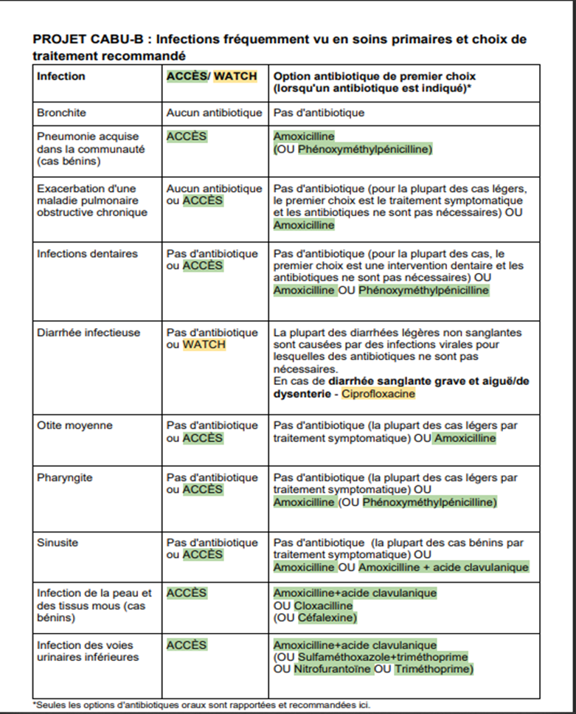

## Acute fever with no other signs

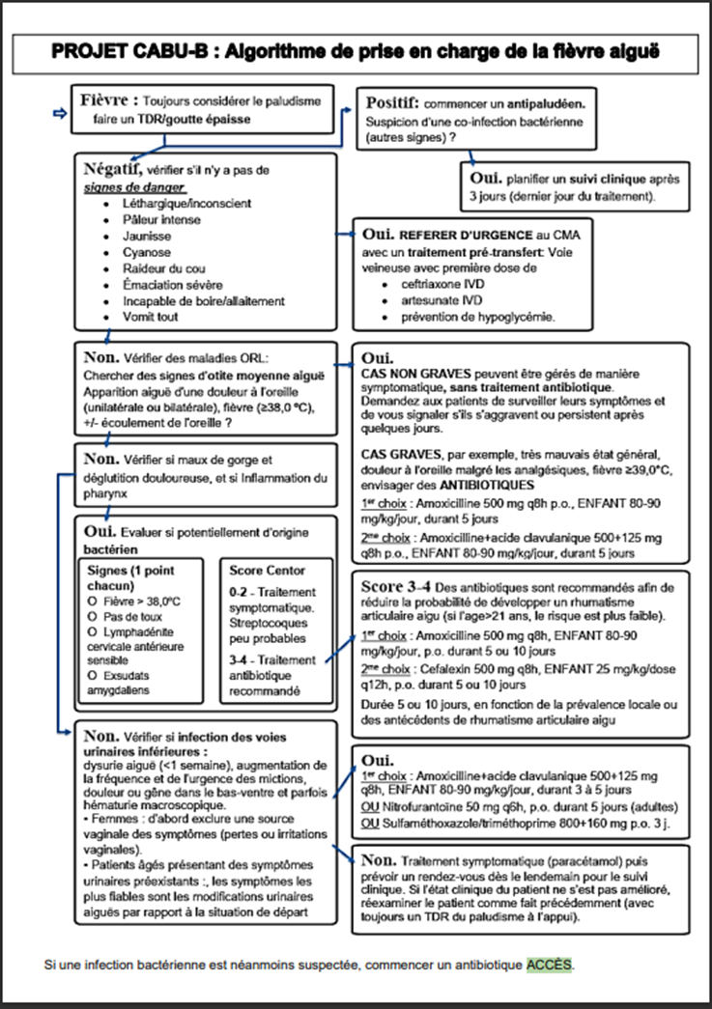

## Acces / Watch antibiotics found at the market

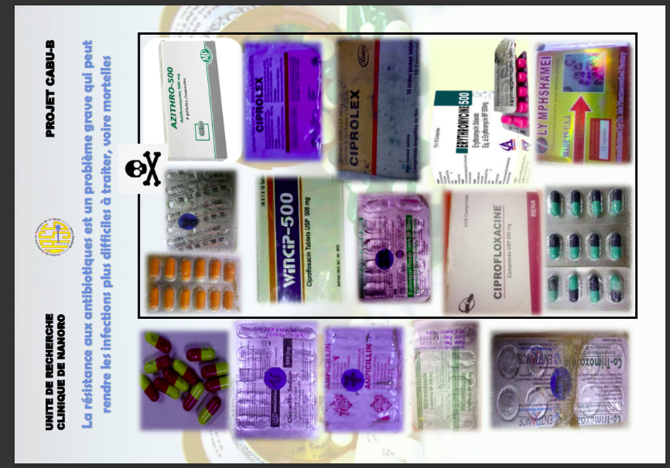

# Bibliographical references

Basic principles for effective communication

Brems, C. (2001). *Basic Skills in Psychotherapy and Counselling*. Brooks/Cole CENGAGE Learning.

Greene, J. O., & Burleson, B. R. (2003). *Handbook of Communication and Social Interaction Skills*. LAWRENCE ERLBAUM ASSOCIATES, PUBLISHERS.

Hugman, B. (2009). *Healthcare Communication*. Pharmaceutical Press.

Mersham, G., & Skinner, C. (2007). *Communication & Public Relations*. Heinemann.

Ratna, H. (2019). The importance of effective communication in healthcare practice. *Harvard Public Health Review*, *23*.

Zohar, I. (2015). "The art of negotiation" Leadership skills required for negotiation in time of crisis. *Procedia - Social and Behavioral Sciences*, *209*(July), 540-548. https://doi.org/10.1016/j.sbspro.2015.11.285